
Bariatric Resource Services
Operations Guide

Table of Contents
Operations Guide Overview 1
Health Care Provider On-Boarding Process 1
Clinical Sciences Institute Centers of Excellence Network Qualification Process 1
Network Relations 1
Overview of Health Care Provider Implementation Activities 1
The OptumHealth Care Provider RFI 2
Contract Implementation 2
Health Care Provider Training 2
Health Care Provider On-boarding 2
Customer Service Contact Guide 3
Payer Client Procedures 4
UnitedHealthcare Administrative Guide 4
Provider Participation Rules: OptumHealth Bariatric Centers of Excellence Network 5
Notification Form 7
Importance of the Notification Form 7
NF Process 7
Bariatric Notification Form 8
Locating the Payer Case Manager on the NF 8
Communication with the Payer Case Manager 8
When to Contact the Payer Case Manager 9
Claims Submission 10
Where to Submit Claims 10
Multiplan or Direct OputmHealth Agreements…………………………………………………………..10
Integrated Health Plan 10
UnitedHealtcare 10
Timely Filing 11
What Happens to Claims Upon Submission to OptumHealth? 12
Claims Intake and Pricing Process Flow 12
Priced Claims Payment Process 12
Provider Web site 13
Locating the Notification Form 13
Active Network Client List 15
Claims 16
Claims that are Closed or Sent Back to the Health Care Provider 16
Missing Claims 17
Patient Claims List 18
Checking Repriced Claims 18
Manage Claims – Patient Claims Detail 18
Patient Rejected Claims List 19
Claims Pricing and Payment Process 20
Process Overview and Guidelines 20
Closed Case List on 21
Claims Status Process 22
Appendix A: URNProv Page Examples and Field Descriptions 23
Active Case List 24
Patient Detail 25
Patient Notes 27
Closed Case List 28
Patient List (Claims) 29
Patient Claims List 30
Patient Claim Detail 32
All Claims Line Item Detail 34
Electronic Claims Inventory Summary 36
Electronic Claims Inventory Detail page 37
Health Care Provider Closed/Rejected Claims 38
Patient Closed/Rejected Claims 39
APPENDIX B: GLOSSARY OF Terms & Acronyms 41
Glossary of Terms 41
Glossary of Acronyms 43

Operations Guide Overview
The purpose of this guide is to provide you with an ongoing reference tool that includes critical information regarding operational processes at OptumHealth.

Health Care Provider On-Boarding Process
As contracts are negotiated between your medical center and OptumHealth, information is gathered that will facilitate the on-boarding process. On-boarding activities include:
- The Clinical Sciences Institute (CSI) Centers of Excellence network qualification process.
- An initial overview session between your OptumHealth Network Relations Representative and designated representatives from your medical center to learn about your processes and medical center structure.
- A request for information (RFI) to gather important contact and operational information about your programs.

Clinical Sciences Institute Centers of Excellence Network Qualification Process
OptumHealth’s Clinical Sciences Institute conducts an initial qualification process for all new Bariatric programs. This process determines if your medical center qualifies to be included in the OptumHealth Bariatric Centers of Excellence network. Additionally, OptumHealth requires that all participating programs in our Centers of Excellence network complete the evaluation process on an annual basis. This process helps ensure that our customers have access to only those programs that demonstrate continued clinical excellence in their field.
Critical health care provider information is captured from both the annual survey and RFI processes as a way to provide accurate and current information to our payer customers and patients about your programs. It is important to complete all information requests in a timely manner to help ensure payers are provided the most current information.

Network Relations
The Network Relations Team is your main operational contact for all OptumHealth Bariatric Centers of Excellence medical centers. Your medical center will be assigned a Network Relations Representative during the implementation process. The responsibilities of the Network Relations Team include:
- Provider training and on-boarding
- Contract interpretation
- Operational issues
- Escalated claims pricing and payment issues.

Overview of Health Care Provider Implementation Activities
Upon notification of a new health care provider agreement, a Network Relations Representative will be assigned to your medical center. The Network Relations Representative will contact your medical center to discuss the following:
- Overview of the OptumHealth Bariatric Centers of Excellence network
- The Request for Information (RFI) - important contact and operational information about your programs.
- Scheduling a training session with your clinical and billing staff
- BRS Operations Guide
Questions your medical center may have during the time period surrounding the implementation of a new or amended agreement should be directed to your designated Network Relations Representative.

The OptumHealth Care Provider RFI
The Request for Information (RFI) enables OptumHealth to gather detailed, program-specific operational information. The RFI will be forwarded to your medical center for completion following the overview call from your Network Relations Representative.
Timely completion of the RFI is imperative in order to effectively enter your programs into the OptumHealth systems and market your medical center to our payer customers and patients. If the RFI is not completed and returned to OptumHealth, it may impact patient referral as well as claims processing and payment.
It is critical that you notify OptumHealth when providers (Bariatric surgeons) contacts, address, telephone or Web site information change at your medical center, so updates can be made on all OptumHealth systems (Web sites, claims payment, marketing, etc.).

Contract Implementation
Upon receipt of fully executed contract, OptumHealth will enter the terms and provisions of your contract to our systems. Typically, this process is completed without additional input from your medical center based on timely submission of the RFI. However, if the RFI has not been returned, the assigned Network Relations Representative will contact you to obtain the information needed to add your contract to OptumHealth’s systems.

Health Care Provider Training
Concurrent with the execution of a new agreement, training will be scheduled with clinical and billing staff at your medical center. All processes and tools provided by United Resource Networks and referenced in this guide will be discussed during these training sessions.

Health Care Provider On-boarding
Following the execution of a new agreement or amendment, the Network Relations Representative will work with the main operations contact at your medical center to help ensure that all operational processes with OptumHealth are functioning.
The on-boarding phase of the implementation process will end when operations are established to the mutual satisfaction of all parties (operational contact(s) at your medical center, OptumHealth Network Relations Representative and Supervisor).
Once the on-boarding period has ended, service responsibilities between your medical center and OptumHealth will reside with the customer service and network relations teams.

Customer Service Contact Guide
If your medical center has questions about working with OptumHealth, please refer to the table below for contact information. If you encounter an issue that is not listed below, please contact our customer service team at:
(877) 801-3507
Your inquiry will be directed to the appropriate area for resolution.
Topic / Question | Contact Who? | How?
Questions about information on the patient’s BRS Membership card, Notification Form (NF) or to obtain a copy of an NF form. | Network Relations | (877) 801-3507
We have not yet received an NF for a patient that is currently being seen at our medical center. | Payer Case Manager | (877) 801-3507
Payment status for UnitedHealthcare patient’s claims. | UnitedHealthcare Customer Service | Refer to UnitedHealthcare Provider Administrative Guide
Repricing status of external client claims submitted by my organization. | Provider Web site | www.myoptumhealthcomplexmedical.com/provider  > Manage Claims
Payment status of external client claims submitted by my organization. | Network Relations | (877) 801-3507
Questions about patient eligibility, inpatient preadmission, patient benefit information. | Payer Case Manager | See case manager contact information on NF.
Administrative issues on a Bariatric case requiring special coordination between the health care provider and OptumHealth | Network Relations | (877) 801-3507
Contract interpretation | Network Relations | (877) 801-3507
Contract negotiation | Network Development | (877)801-3507  Ask for your designated OptumHealth Contracting Representative
Request for training | Network Relations | (877) 801-3507
Questions about EDI claims submission | Network Relations | (877) 801-3507
Questions on the annual survey or the Clinical Sciences Institute qualifying process | Clinical Sciences Institute | (877) 801-3507
Questions concerning closed cases | Provider Web site | www.myoptumhealthcomplexmedical.com/provider  > Manage Patients or Manage Claims

Payer Client Procedures
As described in your OptumHealth Agreement, OptumHealth payer clients may have procedures that health care providers must follow, such as prior authorization and eligibility verification. Please contact the member's primary payer to obtain such procedures, or you may refer to any existing procedure documentation that your organization has from the member's primary payer; for example, your organization may have United Healthcare's Provider Administrative Guide that it follows for UnitedHealthcare membership.

UnitedHealthcare Administrative Guide
An example of the UnitedHealthcare Administrative Guide is below. Please review this guide for specific procedures around OptumHealth patients. Additional other information about UnitedHealthcare is available online at: www.unitedhealthcareonline.com

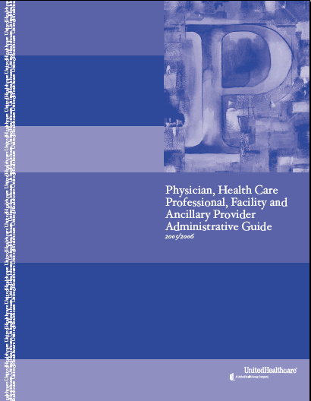
UnitedHealthcare Administrative Guide

Provider Participation Rules:
OptumHealth Bariatric Centers of Excellence Network
Health care providers participating in OptumHealth’s Bariatric Centers of Excellence network must abide with and abide by all provisions below. Failure to adhere to any provision will result in exclusion from the Bariatric Centers of Excellence network.
Criteria
OptumHealth, in conjunction with a multi-disciplinary panel of specialty physicians, develops proprietary criteria upon which you are evaluated for inclusion in OptumHealth’s Bariatric Centers of Excellence network. The evaluation criteria are updated periodically in response to emerging clinical data, or medical techniques and technologies. OptumHealth’s Clinical Sciences Institute (CSI) department performs the health care provider evaluations on an initial and annual basis. You will be evaluated against the following benchmark criteria:
      - Patient surgery volume in total and by surgical procedure type
      - Dedicated Bariatric Surgery unit(s)
      - Multidisciplinary Bariatric surgery patient care team
      - Comprehensive discharge planning
      - Bariatric CMS COE designation
If you do not meet all of the criteria, you will be placed in a Focused Review or removed from the Bariatric Centers of Excellence network.
Compliance with OptumHealth’s Operations Guide
You must comply with all provisions located in OptumHealth’s Operations Guide. This may include, but is not limited, to the following topics:
- Eligibility, Coverage, Prior Approval/Authorization Inquiries – OptumHealth’s or OptumHealth client’s directions should be followed for verifying a prospective patient’s eligibility and level of coverage. You may also be required to request prior approval/authorization on prospective patient’s behalf for services.
- Standards of Practice Guidelines – OptumHealth, along with a panel of Bariatric surgeons and specialty clinicians, may set standards of practice guidelines for Bariatric surgery and Bariatric-related treatment of OptumHealth members or OptumHealth client’s members.
- Claims – The OptumHealth Operations Guide contains information for proper claims submission. You need to fill out all applicable forms and fields before OptumHealth will process the claims.
- Utilization Review – OptumHealth’s guidelines should be followed for furnishing OptumHealth with a utilization review and the appropriate information to allow OptumHealth to perform its own utilization review of a member’s inpatient stay.

Consultation
Please consult OptumHealth’s CSI team at clinical.science@optumhealth.com regarding OptumHealth’s medical policies, quality improvement programs, and utilization management procedures.
Mutually Acceptable Rates and Terms
You and OptumHealth must agree to mutually acceptable rates and terms in the Bariatric Services Agreement for your inclusion in OptumHealth’s Bariatric Centers of Excellence network.
As detailed in the Bariatric Services Agreement, you are reimbursed on a fee-for-service basis with no withholds or bonuses.
OptumHealth’s Annual Survey
As a participating health care provider in OptumHealth’s Bariatric Centers of Excellence network, CSI will send you an annual survey. Health care Providers are given 30 days to complete and return the survey and if requested, may be given a 15-day extension. CSI evaluates your survey data comparing it to their proprietary criteria. If you meet the criteria, you will remain in OptumHealth’s Bariatric Centers of Excellence network. If you do not meet OptumHealth’s criteria, you are subject to a change in network status.
Appeals Process
Your program may appeal OptumHealth’s decision to change your programs network status under certain circumstances. OptumHealth will send you a letter notifying you of your program’s removal from the OptumHealth Centers of Excellence network. The letter will include the reason for the change in network status and will let you know the appeal rights that apply to the decision. Please note that not all adverse decisions are subject to appeal. It is important that you follow the process outlined in the letter.

Notification Form

Importance of the Notification Form
OptumHealth patient referrals are communicated to our Bariatric centers via the Notification Form (NF). The NF should be received prior to the patient’s first visit to your medical center and is used to provide your staff with key information about a patient who has been referred for Bariatric surgery. This Notification Form is an alternative document to communicate the information presented on the patient’s BRS membership card
We suggest that distribution of this information occur as indicated below:
- Clinical staff should be given the contact name and phone number of the payer case manager. This information is used to obtain authorization for care and to provide updates on patient status.
- Billing and administrative staff are notified by the NF that claims are to be sent directly to OptumHealth, Integrated Health Plan (IHP) or United HealthCare depending on the patient’s coverage.
- Your facility is responsible for forwarding the NF sent to any affiliated entities or contacting your affiliates to provide the OptumHealth case effective or surgery date and OptumHealth billing address.
Additionally, we recommend that your administrative system be flagged so that the patient is identified as a OptumHealth Bariatric patient. This will help ensure that Bariatric-related claims are submitted to the appropriate contract holder.
Reminder: It is your organization’s responsibility to verify patient benefits at the beginning of the case.

NF Process
The NF is completed by an OptumHealth case manager/clinical consultant, or by an OptumHealth customer and sent to OptumHealth. A patient record is created within our systems based on the information provided on the NF. The NF is then forwarded to designated contacts at your medical center. (This contact information is collected within the health care provider Request for Information (RFI.)

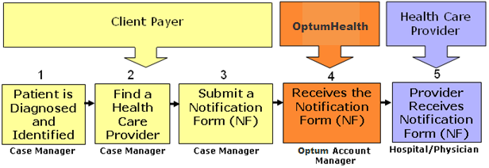
Process Flow for Bariatric Notification Form
In some cases, there may be a 24-hour delay between your receipt of the NF and the new case appearing on the Provider Web site.

Bariatric Notification Form
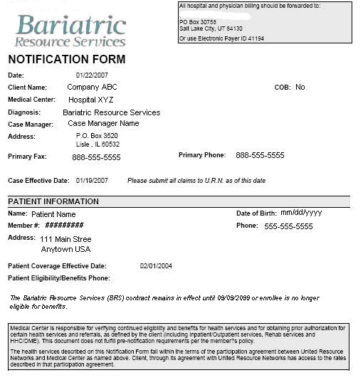
Bariatric Resource Services Notification Form (NF)

Locating the Payer Case Manager on the NF
OptumHealth or Payer case manager contact information is provided on the Bariatric notification form sent to the health care provider for each patient. This information is located in the upper-third of the form.

Communication with the Payer Case Manager
Payer case managers have a variety of critical responsibilities that vary from payer to payer. Normally, they are the contact point for information about benefit eligibility, eligible services, preauthorization of services and discharge planning.
It is important to keep in mind that the OptumHealth or payer case manager is influential in referring patients to Bariatric centers. Their relationship with the clinical contacts within your Bariatric program, as well as the ease with which they can obtain the information they need, has an impact on referral decisions. OptumHealth strongly encourages timely communication with payer case managers to help facilitate administration of patient care and timely payment of claims. Specifically, the date of the bariatric surgery should be communicated to the payer case manager as soon as it has been scheduled.

When to Contact the Payer Case Manager
Noted below is a table that can be used as a reference guide for communication with payer case managers.
When? | Call Who? | About What?
Initial Referral | OptumHealth or Payer Case Manager | - Exchange contact information  - Discuss pre-certification process  - Choose facility  - Identify follow-up plans
Initial Referral | Referring Physicians | - Scheduled date of surgery or other treatment
Bariatric Surgery | OptumHealth or Payer Case Manager and Referring Physician | - Date of admission, pre-certification notification  - Date of scheduled surgery  - Establish follow-up plan for routine inpatient updates  - Discuss discharge planning prior to discharge:  - Home care needs  - DME needs  - Medication needs through an agreed-upon pharmacy  - Follow-up plans  - Establish ongoing communication plan
Post Bariatric Surgery | OptumHealth or Payer Case Manager and Referring Physician | - Discuss changes in patient status as needed.

Always contact the Payer and OptumHealth Case Manager in the case of death. It is also important to keep the referring physician informed throughout the treatment process. Regular communication is the key.

Claims Submission
Multiplan or Direct OptumHealth Agreements
Claims must be sent to the OptumHealth claims team for pricing for cases covered by a Multiplan or direct OptumHealth agreement. Once priced according to the contract, claims will be forwarded to OptumHealth payers for payment.

Where to Submit Claims for Multiplan and OptumHealth cases
All claims filed on both UB-04 and CMS-1500 claims must be forwarded to OptumHealth as indicated below:

Electronic Claims Payer ID Information
OptumHealth
Emdeon and ClaimLynx Payer ID #41194

Paper Claims Address Information
OptumHealth Care Solutions
PO Box 30758
Salt Lake City, Utah 84130

Emergency Claims Submission
In cases of emergency, your medical center can submit claims to OptumHealth using overnight delivery. Please call our toll-free number (877-801-3507) to provide us with notification of overnight claims delivery.
LASON – SCS RMO
Attention: OptumHealth Care Solutions
PO Box 30758
Salt Lake City, Utah 84130

Integrated Health Plan
Claims for cases covered by Integrated Health Plan can be sent to the address on the patient’s BRS membership card.

Where to Submit Claims for Integrated Health Plan (IHP) cases
All claims filed on both UB-04 and CMS-1500 claims must be forwarded to IHP as indicated below:

Paper Claims Address Information
Integrated Health Plan
P.O. Box 48188
St. Petersburg, FL 33743-8188

UnitedHealthcare
Claims for cases covered by UnitedHealthcare can be sent to the address on the patient’s UHC insurance card.

Timely Filing
Your medical center agreement contains a claim filing deadline. Please consult your agreement for the timely filing deadline for your medical center. OptumHealth or its payers, at their discretion, may elect to not accept claims that are submitted after the timely filing deadline.

What Happens to Claims Upon Submission to OptumHealth?
* Note for Multi-plan and direct OptumHealth agreement claims only.
Claims submitted to OptumHealth follow a defined process that allows for timely and accurate pricing prior to submission for payment by our payer customers. Health care provider staff can review the current pricing status of claims submitted on the Provider Web site.

Claims Intake and Pricing Process Flow
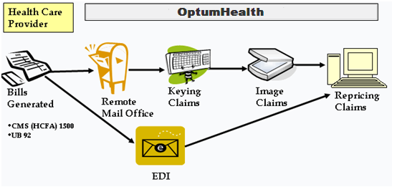
Claims Intake and Pricing Process Flow
A daily summary of claims submitted electronically to OptumHealth can be viewed on myoptumhealthcomplexmedical.com. See Appendix A for details on the EDI Claims Inventory Report

Priced Claims Payment Process
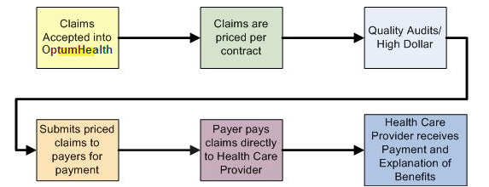
Priced Claims Payment Process
After OptumHealth prices the claims, they are sent to clients along with a report explaining the claims. See Appendix C for an example of a Client Claims Report.

Provider Web site
* Please note that this site will only display patients and claim information for cases utilizing a Multiplan or OptumHealth direct contract agreement.
OptumHealth has developed a secured Web site to specifically address the needs of our contracted facilities. The Web site provides access to important information about your active and closed cases, clinical dates and claims information.
Web site Address: www.myoptumhealthcomplexmedical.com
Staff at your medical center can request access to the site by clicking on the link entitled ‘Request Access’ on the home page. Users are required to complete an online form requesting demographic and role-based information before access is granted to the site.
OptumHealth grants access to affiliated providers upon agreement from the medical center’s managed care contact approval.
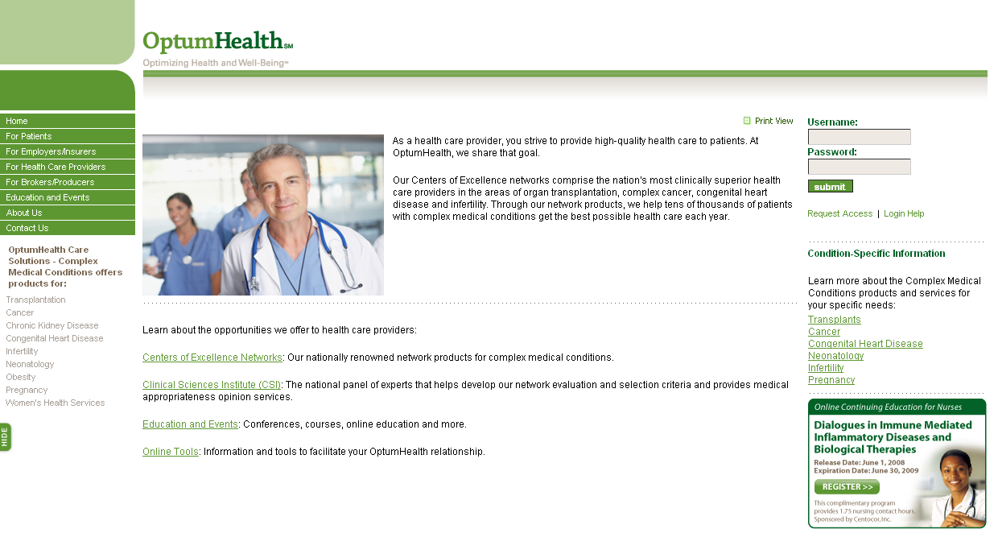
Your staff can request access here
Myoptumhealthcomplexmedical.com – Login Page
Detailed explanation of processes and procedures for each area of the site is provided in Appendix A of this document.

Locating the Notification Form
In addition to NF distribution via secure email or fax, patient Notification Forms can be found under the Manage Patient menu item (Manage Patients > Notification Form). Clicking on a patient name will open the NF (Adobe Acrobat Reader Required)
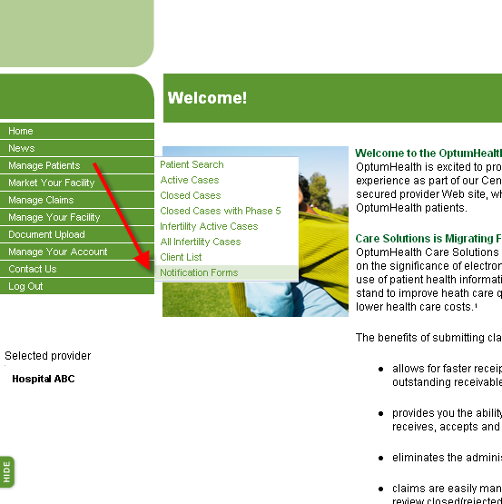
myoptumhealthcomplexmedical.com --- Notification Forms
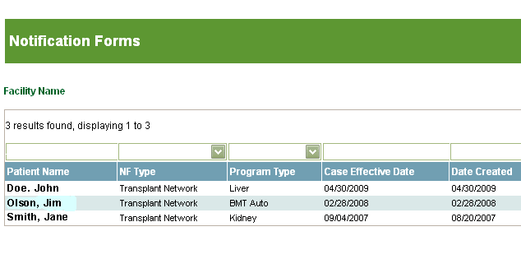

Active Network Client List
A current copy of the Active Client List can be easily obtained on the site under the Manage Patient menu item (Manage Patients > Client List). This list will enable you to identify OptumHealth contracted payers that can refer patients to your medical center.
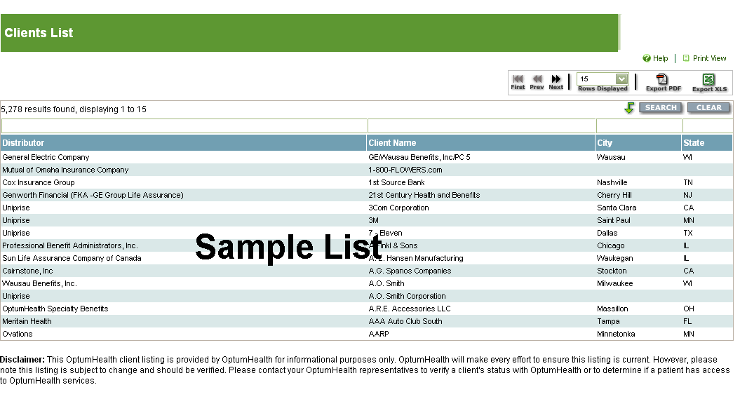
myoptumhealthcomplexmedical.com – Clients List

Claims
Claims submitted to OptumHealth can be viewed on the Provider Web site in two locations: EDI Claims Inventory Summary and Patient Claims List.
Electronic Claims Summary
Your medical center can view claims submitted electronically via the OptumHealth EDI Claims Inventory tool. The Electronic Claims Inventory is located under the Manage Claims menu item (Manage Claims > EDI Claims Inventory). Details on the Electronic Claims Inventory are available in Appendix A.
Note: If your organization does not submit claims electronically, this web page will be blank.
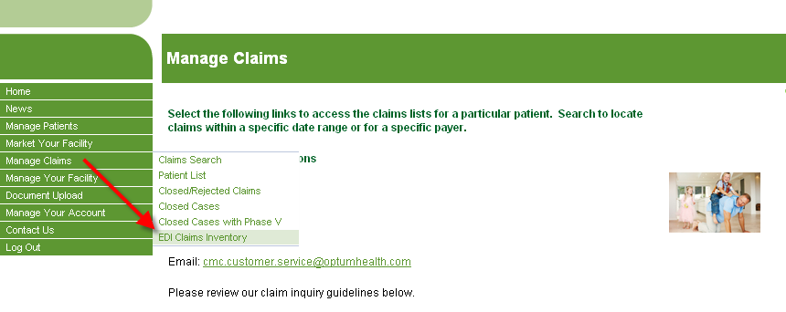
myoptumhealthcomplexmedical.com – EDI Claims Inventory Summary

Claims that are Closed or Sent Back to the Health Care Provider
Occasionally OptumHealth will close claims submitted by health care providers and accepted into our system. Reasons for claims closure include:
- Duplicate claims
- Missing or invalid data
- Claim submission by an unaffiliated provider
- Claims dates of service that do not fall into the eligibility period for the patient
A list of closed or rejected claims is available on the site by clicking on the Manage Claims menu item. Examples of the rejected claims listed, viewed by medical center or patient, are provided below. Details on the Rejected Claims Lists are available in Appendix A.
Some claims are rejected before entry into our system because the patient’s name, date of birth or the health care provider’s tax identification number does not match information set up for the patient’s case or the medical center. These claims will not receive a rejection letter nor will they display on myoptumhealthcomplexmedical.com.
Please Note: OptumHealth does not return duplicate claims to the health care provider.
NAVIGATION: Manage Claims > Closed/Rejected Claims
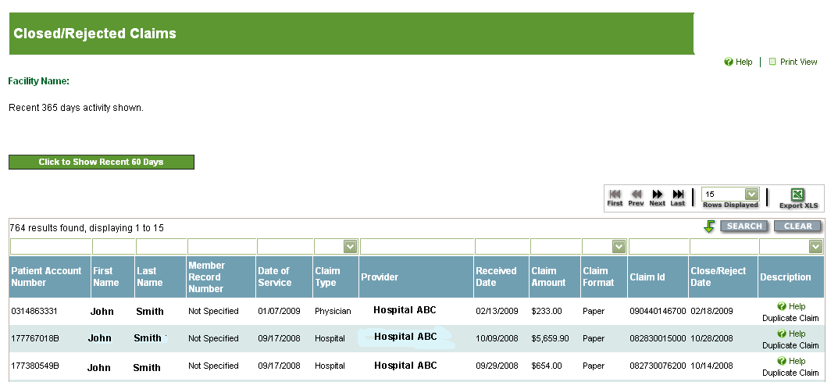
myoptumhealthcomplexmedical.com – Closed/Rejected Claims by Medical center

Missing Claims
If your medical center has submitted a claim that does not display on the Patient Claims List or the Closed/Rejected list and you cannot locate the claim online within one week of its submission, please resubmit the claim to OptumHealth.

Patient Claims List
The Patient List shows all claims received by OptumHealth, by patient name. The Patient List is located under the Manage Claims menu item (Manage Claims > Patient List).

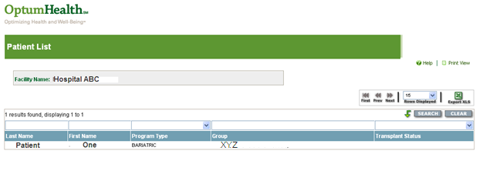
myoptumhealthcomplexmedical.com – Patient List
All claims for individual patients shown on the claims list can be viewed by simply clicking on the patient’s name (the patient name is a hyperlink). You can also access the Patient Claims List from the Manage Claims menu item (Manage Claims > Patient List > select your patient.
Summary case information (including clinical dates) is provided on this page, including:
- Program type (TYPE OF BARIATRIC)
- Case effective date
- Inactive date
- Case close reason
An additional search feature provides the ability to search for claims by date of service (DOS). Details on the Patient Claims List are available in Appendix A.
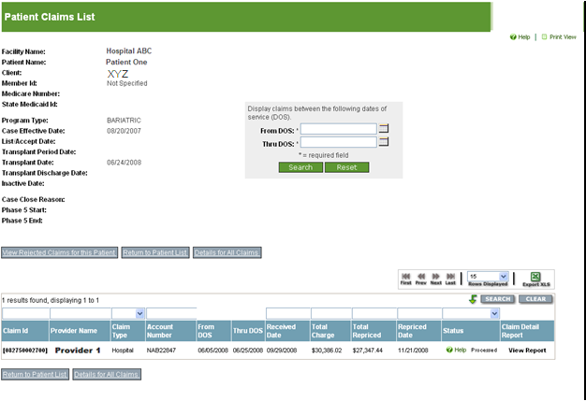
myoptumhealthcomplexmedical.com – Patient Claims List

Checking Re-priced Claims
You can check the processing status of your claims directly on the Provider Web site. The Patient Claims List displays the claim ID number and status of each claim. Claims that have been priced will display a status of ‘processed’. These claim numbers always end in ‘00’. The processed status means that OptumHealth has priced the claim based on the contractual agreement with your medical center.
If the claim requires adjustment, it will be priced again. A second line of information will display reflecting this status. The status on the original claim line item will change to ‘adjusted.’ The second line will display a status of ‘processed.’ The last two digits of the claim ID will also change to ‘01’. This also indicates that an adjustment to the original claim has been made. The original claim remains available for view with the original claim number.
myoptumhealthcomplexmedical.com – Adjusted Claim on Patient Claims List

Manage Claims – Patient Claims Detail
You can view details about each claim listed on the Patient Claims List by clicking on the claim number (a hyperlink appears directly under the claim number) or the View All Claim Detail button at the bottom of the page. You can access the Patient Claim Detail page from the Manage Claims menu item (Manage Claims > Patient List > select your patient > select the claim number.) Details on the Patient Claim Detail page are available in Appendix A.
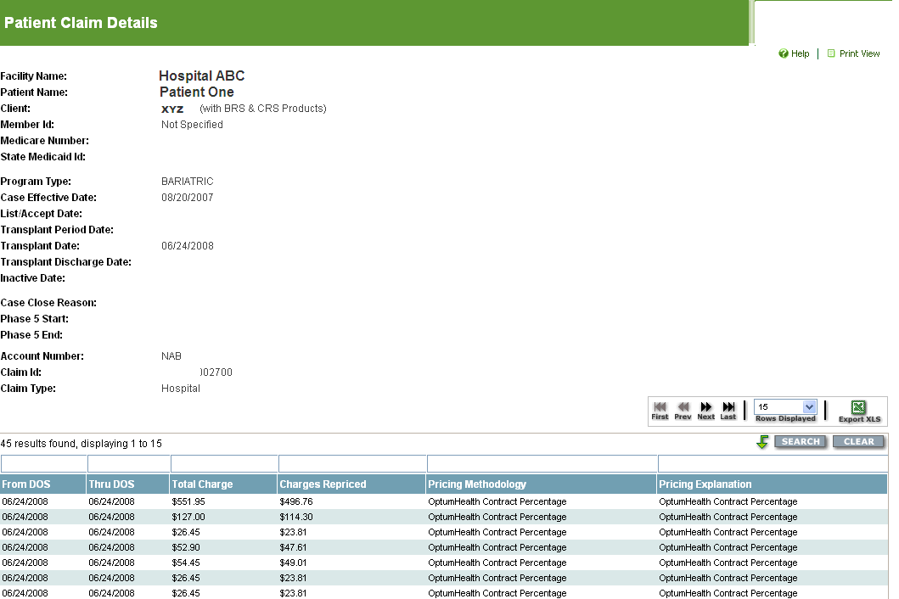

myoptumhealthcomplexmedical.com – Patient Claim Details

Patient Rejected Claims List
You can also view rejected claims, by patient, by clicking on the View Rejected Claims for this Patient button located at the bottom of the Patient Claims List page. These lists are accessed through Manage Claims menu item (Manage Claims > Patient List > select your patient > View Rejected Claims for This Patient).
myoptumhealthcomplexmedical.com – Patient Rejected Claims List

Claims Pricing and Payment Process

Process Overview and Guidelines
- OptumHealth prices claims received from your medical center based on your specific OptumHealth agreement.
- OptumHealth sends priced claims to payers for processing.
- OptumHealth payers apply patient benefits to the priced claim amount and determine which services are eligible for reimbursement. Member responsibility amounts such as copayments, coinsurance and deductibles are applied.
- Your medical center may bill the patient for any amounts that are the responsibility of the patient. These amounts will be shown as patient responsibility on the explanation of benefits/health care provider remittance advice.
- If there is an overpayment, OptumHealth will notify your medical center of the overpayment via a Refund Notice. We will also notify the payer of an underpayment on the final invoice.

Closed Case List
We provide a Closed Case list on the Provider Web site.
- Cases without any claims submitted in the previous 24 months are visible in this area. This list can be accessed on the site from the Manage Claims menu item (Manage Claims > Closed Cases). Details on the Closed Case List are available in Appendix A.
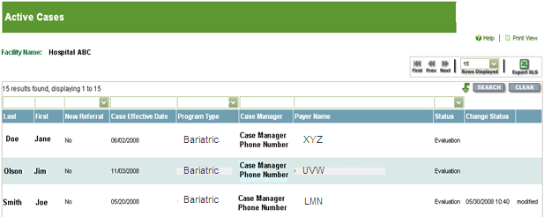
The Closed Case Reports are also accessible under the Manage Patients and Manage Claims menu items.

Claims Status Process
You can view the pricing status of claims submitted by your medical center using the Patient Claims List. If after 45 days from the priced date you do not have payment from a payer, you can submit a claims inquiry to OptumHealth. Inquiries are tracked by the Network Relations team. Assigned team members will contact payers, as needed, to verify payment status.
There are three ways you can submit inquiries as illustrated in the table below:
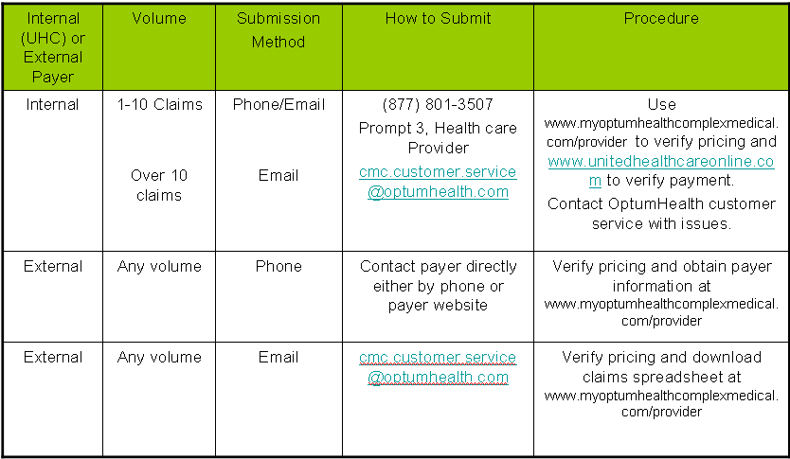
OptumHealth Claims Status Submissions
Additionally, you can use the Patient Claims List to export a list of claims to Microsoft Excel. By doing so, you can customize the information submitted for status and send to OptumHealth via secure email.
Be sure to review the claims status guidelines that are posted (Manage Claims > Claims Status Spreadsheet Template) for additional details.
The following is a summary of the Network Services Policy covering handling of Customer Service Inquiries:
Following submission of an inquiry, you will be issued an inquiry ID number to track the progress of your status request to resolution. If you submit your request by phone, the inquiry ID number will be provided by the end of the call. If your request was submitted via fax or email, the inquiry ID number will be returned within 24 hours to the contact provided on the request.
Your Network Relations Representative will provide regular status updates on the resolution of your request. The frequency of these updates will vary depending on the number of cases, claims and payer(s) included in the request.

Appendix A: Page Examples and Field Descriptions
This appendix provides details of the pages available within the Provider Web site. A graphic of each page is provided accompanied by descriptions of each field. Navigation to the page is also indicated.
For additional information or training on the site, please contact your Network Relations Representative.

Active Case List
This read-only page provides a list of all active cases at your medical center. The fields located above the column headings allow sorting and/or filtering on one or more fields of data. To access Patient Detail or notes, simply click on the patient name hyperlink.
Note: You can use the field or drop down list above the Program Type field to see only patients.
This information can also be exported in either Excel or PDF formats.
Navigation: Manage Patients > Active Cases
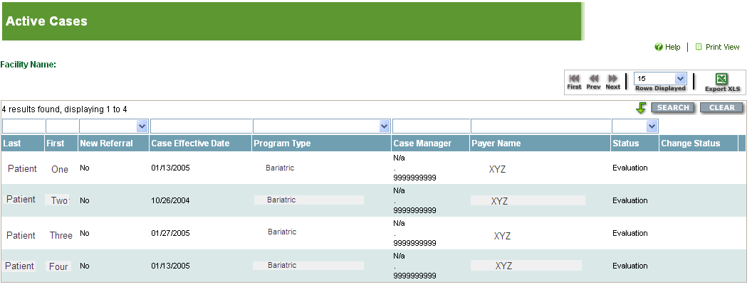

Active Case List
Field Name | Field Description
Last | Displays the patient’s last name. Each name links to the Patient Detail page.
First | Displays the patient’s first name. Each name links to the Patient Detail page.
CED | Displays the case effective date (CED) for the case.
New Referral | Yes/No field that indicates whether the case is a new referral within the last 30 days.
Program Type | Displays type of Bariatric.
Case Manager | Displays the payer case manager’s name and phone number.
Payer Name | Displays the payer for the patient.
Transplant Status | This field is not applicable to Bariatric cases.
Change Status | Displays the last date status was changed on the patient record.

Patient Detail
This page displays details of the patient’s case. Users with access can enter clinical dates, donor information and notes on the case. The patient notes link accesses the Patient Notes page allowing case note entry.
Navigation: Manage Patients > Active Cases > select your patient
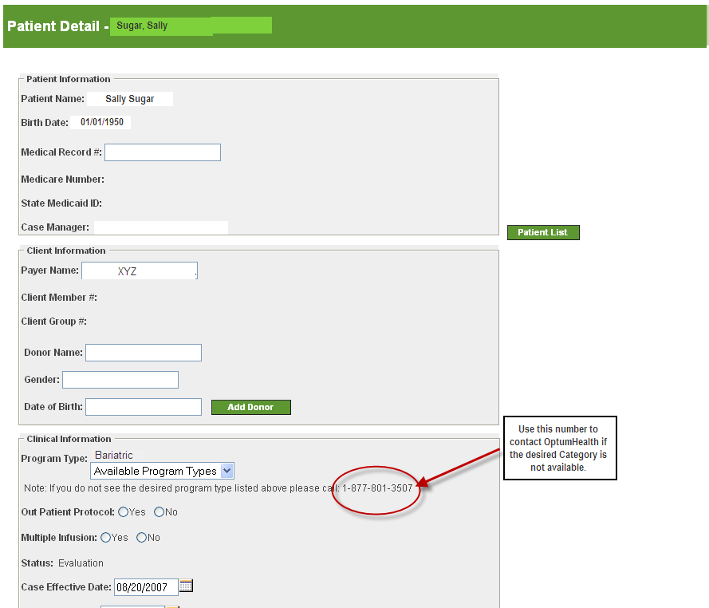
Active Case -- Patient Detail
Field Name | Field Description
Patient Name | Displays the patient’s name.
Birth Date | Displays the patient’s date of birth.
Medical Record # | Optional field that allows you to enter your medical center’s medical record number for the patient.
Case Manager | Displays the payer case manager’s name and phone number.
Payer Name | Displays the payer’s name.
Client Member # | Displays the payer’s (customer) member number.
Client Group # | Displays the payer’s (customer) group number.
Donor Name | This field is not applicable to Bariatric cases.
Gender | Text box allowing you to enter the donor gender.
Date of Birth | Text box allowing you to enter the donor date of birth.
Program Type | Displays the Bariatric diagnosis.
Status | Displays the current status for the patient.
Case Effective Date | Allows for entry and display of the case effective date (CED) for the case.
Accept/List Date | This field is not applicable to Bariatric cases.
Transplant Admit Date | This field is not applicable to Bariatric cases.
Transplant Date | This field is not applicable to Bariatric cases.
Transplant Discharge Date | This field is not applicable to Bariatric cases.
OptumHealth Case Inactive Date | Allows entry of an inactive date for the case.
Case Close Reason | Once an inactive date has been entered, a case close reason must be selected from the drop-down.
Comments | A text field allowing a comment when the case has been closed for the reason ‘Other’.
Patient Notes Link | Clicking on this link opens the data entry form for patient notes.
Date | Displays the date of existing patient notes.
Entered by | Displays the name of the user entering the patient note.
Notes | Displays the text of the note entered.

Patient Notes
Navigation: Manage Patients > Active Cases > select your patient > Patient Notes

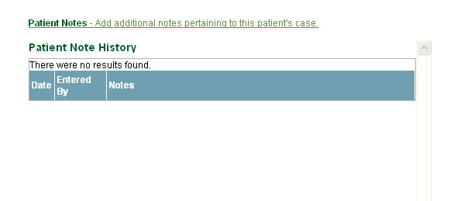

Active Case – Patient Detail & Patient Notes
Field Name | Field Description
First Name | Displays the first name of the person entering the patient note.
Last Name | Displays the last name of the person entering the patient note.
Date | Displays the date that the patient note was entered.
Notes | Displays the text of the patient note.
Enter Patient Notes | Text field allowing entry of a patient note.
Save button | Saves the patient note.
Back button | Returns the user to the Patient Detail page.

Closed Case List
The Closed Case list shows all cases with a current status of closed. The fields located above the column headings allow sorting and/or filtering on one or more fields of data. To access patient detail, simply click on the patient name.
Note: You can use the field or drop down list above the Program Type field to see only Bariatric patients.
This information can also be exported in either Excel or PDF formats.
Navigation: Manage Patients > Closed Cases or
Manage Claims > Closed Cases
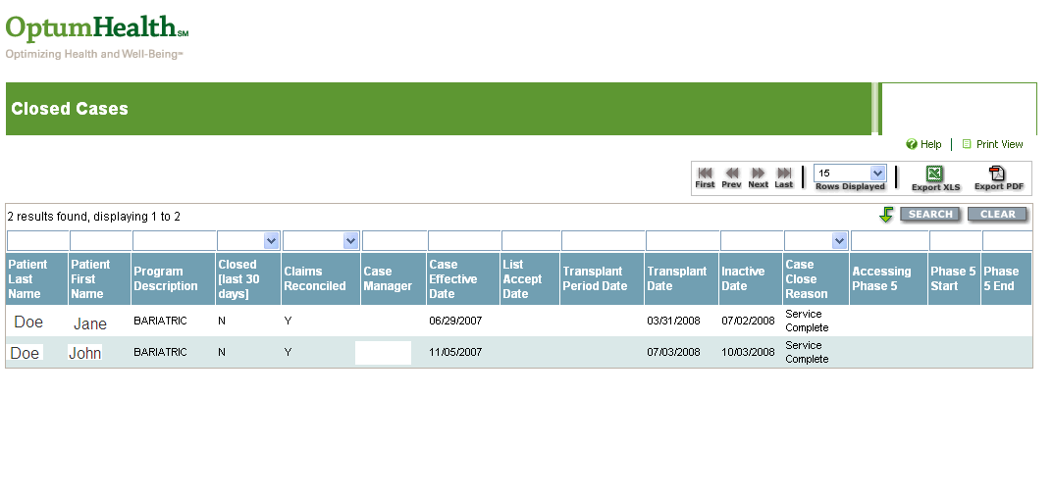
Closed Cases
Field Name | Field Description
Patient Last Name | Displays the last name of the patient.
Patient First Name | Displays the first name of the patient.
Patient Name | Links to any patient notes.
Program Description | Displays Bariatric diagnosis.
Closed [last 30 Days] | Yes/No flag that indicates whether the case has been closed within the last 30 days.
Claims Reconciled | This field is not applicable to Bariatric cases.
Case Manager | Displays the payer case manager’s name.
Case Effective Date | Displays the case effective date (CED) for the case.
List Accept Date | This field is not applicable to Bariatric cases.
Transplant Period Date | This field is not applicable to Bariatric cases.
Transplant Date | This field is not applicable to Bariatric cases.
Inactive Date | Displays the inactive date for the case.
Case Close Reason | Displays the reason the case was closed.
Phase 5 Start | This field is not applicable to Bariatric cases.
Phase 5 End | This field is not applicable to Bariatric cases.

Patient List (Claims)
The Patient List is a read-only search screen. The fields located above the column headings allow sorting and/or filtering on one or more fields of data. To access the patient claim information, simply click on the patient name.
Note: You can use the field or drop down list above the Program Type field to see only Bariatric patients.
This information can also be exported in Excel or PDF formats.
Navigation: Manage Claims > Patient List
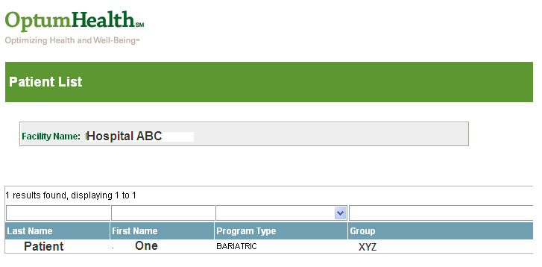

Patient List
Field Name | Field Description
Facility Name | Displays the health care provider name.
Last Name | Displays the last name of the patient.
First Name | Displays the first name of the patient.
Program Type | Displays Bariatric diagnosis.
Group Name | Displays the payer group name.
Transplant Status | This field is not applicable to Bariatric cases.

Patient Claims List
The Patient Claims List shows all claims processed by OptumHealth for an individual patient. The fields located above the column headings allow sorting and/or filtering on one or more fields of data. To access detail on an individual claim, simply click on the claim ID hyperlink.
This information can also be exported in Excel or PDF formats.
There is also a date of service (DOS) search feature that can be used to locate claims for the patient during a specified date range.
Navigation: Manage Claims > Patient List > select your patient

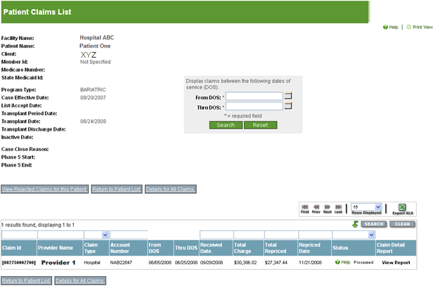
Patient Claims List
Field Name | Field Description
Facility Name | Displays the health care provider name.
Patient Name | Displays the patient’s first and last name.
Client: | Displays the payer’s name.
Member ID | Displays the patient’s member ID as entered on the Patient Detail page.
Program Type | Displays the Bariatric program type.
Case Effective Date | Displays the case effective date (CED) for the case.
List/Accept Date | This field is not applicable to Bariatric cases.
Transplant Period Date | This field is not applicable to Bariatric cases.
Transplant Date | This field is not applicable to Bariatric cases.
Inactive Date | Displays the date the case was closed.
Case Close Reason | Displays the reason the case was closed.
Phase V (5) Start | This field is not applicable to Bariatric cases.
Phase V (5) End | This field is not applicable to Bariatric cases.
Claim ID | Displays the claim ID number.
Provider Name | Displays the name of the provider that submitted the claim.
Claim Type | Displays the type of claim submitted (physician or hospital).
Account Number | Displays the account number provided on the claim.
From DOS | Displays the start date of services on the claim.
Thru DOS | Displays the end date of services on the claim.
Claim Received Date | Displays the date the claim was received by OptumHealth
Total Charge | Displays the total charge on the claim.
Total Repriced | Displays the repriced amount of the claim.
Claim Repriced Date | Displays the date the claim was repriced by OptumHealth
Status | Displays the claim’s current pricing status.
Details for All Claims | This button opens a page listing line item detail of all claims for the patient.

Patient Claim Detail
The Patient Claim Detail page provides line item detailed information on an individual claim. Simply click on the Claim ID number to access line item detail for that claim. The fields located above the column headings allow sorting and/or filtering on one or more fields of data. To access detail on an individual claim, simply click on the claim ID hyperlink.
This information can also be exported in Excel or PDF formats.
Navigation: Manage Claims > Patient List > select your patient > select the claim ID number
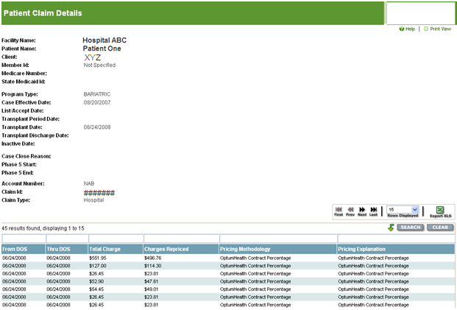
Patient Claim Details
Field Name | Field Description
Facility Name | Displays the health care provider name.
Patient Name | Displays the patient’s first and last name.
Client: | Displays the payer’s name.
Member ID | Displays the patient’s member ID as entered on the Patient Detail page.
Program Type | Displays the Bariatric diagnosis.
Case Effective Date | Displays the case effective date (CED) for the case.
List/Accept Date | This field is not applicable to Bariatric cases.
Transplant Period Date | This field is not applicable to Bariatric cases.
Transplant Date | This field is not applicable to Bariatric cases.
Transplant Discharge Date | This field is not applicable to Bariatric cases.
Inactive Date | Displays the date the case was closed.
Case Close Reason | Displays the reason the case was closed.
Phase 5 Start | This field is not applicable to Bariatric cases.
Phase 5 End | This field is not applicable to Bariatric cases.
From DOS | Displays the start date of services on the claim.
Thru DOS | Displays the end date of services on the claim.
Total Charges | Displays the charges billed on the claim.
Charges Repriced | Displays the repriced amount of the claim.
Pricing Methodology | Displays the pricing methodology used to price the claim.
Pricing Explanation | Displays an explanation of how the claim was repriced based on the health care provider agreement.

All Claims Line Item Detail
The All Claims Detail page provides line item detailed information on every claim submitted. The fields located above the column headings allow sorting and/or filtering on one or more fields of data. To access detail on an individual claim, simply click on the claim ID hyperlink.
The information displayed can also be exported in Excel or PDF formats.
Navigation: Manage Claims > Patient List > select patient name > Details for All Claims (at bottom)
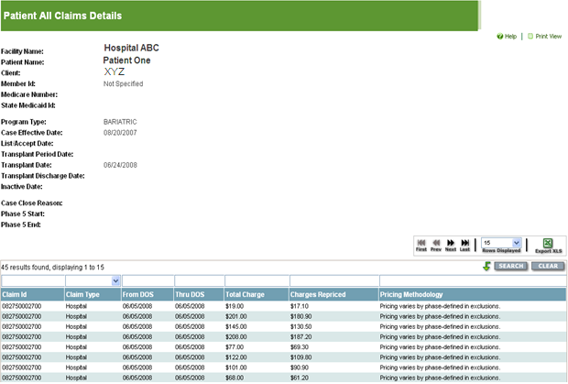

Patient All Claims Detail
Field Name | Field Description
Facility Name | Displays the health care provider name.
Patient Name | Displays the patient’s first and last name.
Client: | Displays the payer’s name.
Member ID | Displays the patient’s member ID as entered on the Patient Detail page.
Program Type | Displays the Bariatric diagnosis.
Case Effective Date | Displays the case effective date (CED) for the case.
List/Accept Date | This field is not applicable for Bariatric cases.
Transplant Period Date | This field is not applicable to Bariatric cases.
Transplant Date | This field is not applicable to Bariatric cases.
Transplant Discharge Date | This field is not applicable to Bariatric cases.
Inactive Date | Displays the date the case was closed.
Case Close Reason | Displays the reason the case was closed.
Phase 5 Start | This field is not applicable to Bariatric cases.
Phase 5 End | This field is not applicable to Bariatric cases.
Claim ID | Displays the claim ID number.
Claim Type | Displays the type of claim submitted (physician or hospital).
From DOS | Displays the start date of services on the claim.
Thru DOS | Displays the end date of services on the claim.
Total Charge | Displays charges billed on the claim.
Charges Repriced | Displays repriced amount of the claim.
Pricing Methodology | Displays the pricing methodology used to price the claim.

Electronic Claims Inventory Summary
The Electronic Claims Inventory Summary page provides a daily summary of the status of claims submitted through EDI. This page displays the number of electronic claims received along with the processing status of the claim(s). To access claim detail information for a specific day, simply click row for the date and you will access the EDI Claim Inventory Detail page.
The information displayed can also be exported in Excel or PDF formats.
Navigation: Manage Claims > EDI Claims Inventory > select the health care provider

EDI Claims Inventory Summary
Field Name | Field Description
Date | Displays the date the electronic claims were received by OptumHealth
Status | Displays the processing status of the claim(s)
Count | Displays the number of claims for each status.

Electronic Claims Inventory Detail page
The Electronic Claims Inventory Detail page provides the detailed electronic claim information for each claim received on that date, including the claim processing status.
The information displayed can also be exported in Excel or PDF formats.
Navigation: Manage Claims > EDI Claims Inventory > select the health care provider > select a date
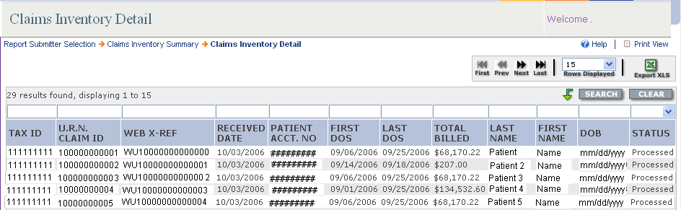
EDI Claims Inventory Detail
Field Name | Field Description
Tax ID | Displays the tax ID of the health care provider submitting the claim.
OptumHealth Claim ID | Identifies the claim number for OptumHealth’s claim system.
Web X-Ref | Identifies the web reference number from the clearinghouse.
Date Received | Displays the date the electronic claim was received.
Patient Acct No | Displays the patient account number submitted on the electronic claim.
First DOS | Identifies the first date of service on the claim submitted.
Last DOS | Identifies the last date of service on the claim submitted.
Total Billed | Displays the total billed charge amount on the claim submitted.
Last Name | Displays the last name of the patient for which the claim was submitted.
First Name | Displays the first name of the patient for which the claim was submitted.
DOB | Displays the date of birth for the patient.
Status | Displays the processing status of the claim(s)

Health Care Provider Closed/Rejected Claims
The Closed/Rejected Claims list enables you to see all claims that have been closed and/or rejected by OptumHealth for your medical center for the last 30 days. You can also select the “Click to Show 365 Days” button to see an expanded list of closed claims. Data displayed on the form cannot be changed. The fields located above the column headings allow sorting and/or filtering on one or more fields of data. The information displayed can also be exported in Excel.
Please Note: OptumHealth does not return duplicate claims.
Navigation: Manage Claims > Closed/Rejected Claims
Closed/Rejected Claims (by Health Care Provider)
Field Name | Field Description
Facility Name | Displays the health care provider name.
Patient Account Number | Displays the patient account number indicated on the submitted claim.
First Name | Displays the patient’s first name.
Last Name | Displays the patient’s last name.
Member Record Number | Displays the patient’s member ID as displayed on the Patient Detail page.
Date of Service | Displays the begin date of services on a claim.
Claim Type | Displays the type of claim submitted (hospital or physician).
Provider | Displays the name of the provider that submitted the claim.
Date Received | Displays the date that OptumHealth received the claim.
Claim Amount | Displays the amount billed on the claim submitted by the provider.
Claim Format | Displays the format in which the claim was submitted (paper or electronic).
Claim ID | Displays the claim ID number.
Close/Reject Date | Displays the date the claim was closed and/or rejected.
Description | Displays a reason why the claim was closed and/or rejected.

Patient Closed/Rejected Claims
The Patient Closed/Rejected Claims List enables you to see all claims that have been closed and/or rejected by OptumHealth, by individual patient. The fields located above the column headings allow sorting and/or filtering on one or more fields of data. The information displayed can also be exported in Excel.
Please Note: OptumHealth does not return duplicate claims.
Navigation: Manage Claims > Patient List > select your patient > View Rejected Claims for this Patient
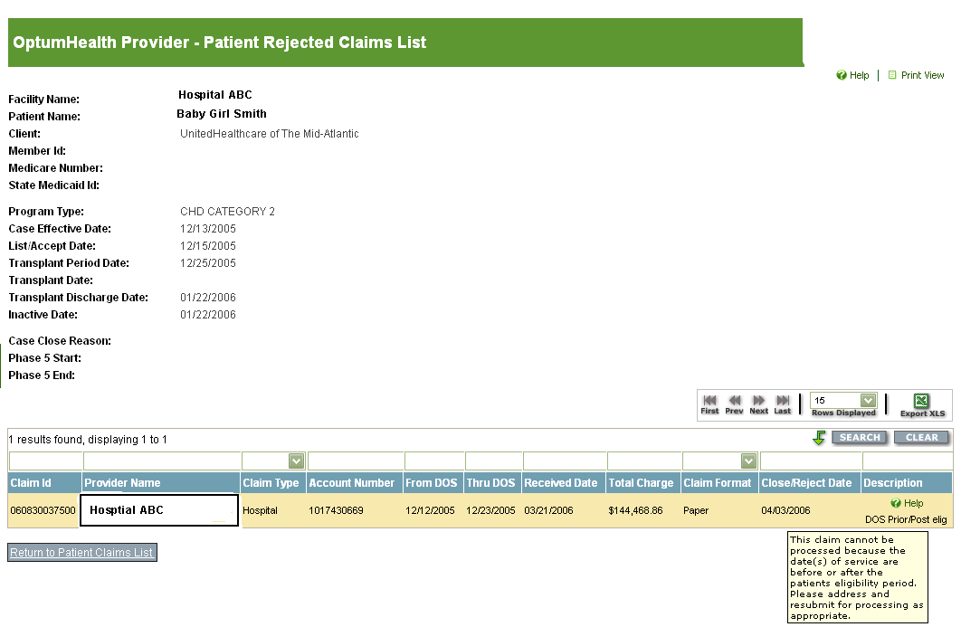
Patient Rejected Claims List
Field Name | Field Description
Facility Name | Displays the health care provider name.
Patient Name | Displays the patient’s name.
Client | Displays the payer’s name.
Member ID | Displays the patient’s member ID as displayed on the Patient Detail page.
Program Type | Displays the Bariatric diagnosis.
Case Effective Date | Displays the case effective date (CED) for the case.
List/Accept Date | This field is not applicable for Bariatric cases.
Transplant Period Date | This field is not applicable to Bariatric cases.
Transplant Date | This field is not applicable to Bariatric cases.
Transplant Discharge Date | This field is not applicable to Bariatric cases.
Inactive Date | Displays the date the case was closed.
Case Close Reason | Displays the reason the case was closed.
Phase 5 Start Date | This field is not applicable to Bariatric cases.
Phase 5 End Date | This field is not applicable to Bariatric cases.
Claim ID | Displays the claim ID number.
Provider Name | Displays the name of the provider that submitted the claim.
Claim Type | Displays the type of claim submitted (hospital or physician).
Account Number | Displays the patient account number indicated on the submitted claim.
From DOS | Displays the start date of services on the claim.
Thru DOS | Displays the end date of services on the claim.
Claim Received Date | Displays the date that OptumHealth received the claim.
Total Charge | Displays the amount billed on the claim submitted by the provider.
Claim Format | Displays the format in which the claim was submitted (paper or electronic).
Close/Reject Date | Displays the date the claim was closed and/or rejected.
Description | Displays a reason why the claim was closed and/or rejected.

APPENDIX B: GLOSSARY OF Terms & Acronyms

Glossary of Terms
Note: If there is a discrepancy between a definition in this Operations Guide and a definition in your Agreement with OptumHealth, the definition in the Agreement supersedes the definition in this guide.
Affiliated Provider | A physician, health care provider or sub-contracted entity that is a party to the health care provider contract with OptumHealth.
Allowable Costs | Charges for services rendered for supplies furnished, by any health care provider, that qualify as covered expenses.
Allowable Days | The inpatient days associated with a case rate.
Billed Claims | The fees for health care services provided to a covered person and submitted by a health care provider. Also referred to as billed charges.
Case Manager | A clinical professional (e.g., nurse, doctor or social worker) who works with patients, health care providers, physicians and insurers to determine and coordinate a plan of medically necessary and appropriate health care. Also referred to as care coordinator.
Ceiling | An operational term used to indicate the stop loss language in some health care provider contracts indicating that the health care provider payment will never be greater than the contract-defined percentage. Also referred to as “inlier.”
Centers of Excellence | A network of qualified health care facilities selected for specific services based on stringent criteria including outcomes and efficiency. For example, an organ transplant managed care program may require members to access transplant services through a Centers of Excellence network.
Claim | Information submitted by a health care provider or covered person that establishes the specific health services provided to a patient and requests reimbursement to the requestor.
Coinsurance | The portion of covered health care costs for which the covered person is financially responsible, usually according to a fixed percentage. Coinsurance often is applied, according to a fixed percentage, after a deductible requirement is met.
Coordination of Benefits (COB) | A provision in a contract that applies when a person is covered under more than one group medical program. It requires that payment of benefits be coordinated by all programs to eliminate over insurance or duplication of benefits.
Copayment | A cost-sharing arrangement in which a covered person pays a specified charge for a specified service, such as $10 for an office visit. The covered person usually is responsible for payment at the time the health care is rendered. Typical copayments are fixed or variable flat amounts for physician office visits, prescriptions or hospital services. Some companies use the term copayment to refer generically to both a flat dollar copayment and coinsurance.
Date of Service | The date health care services were provided to the covered person.
Effective Date | The date a contract becomes effective.
Electronic Data Interchange | The computer-to-computer exchange of business or other information between two medical centers (trading partners). The data may be either in a standardized or proprietary format. Also known as electronic commerce.
Eligibility Dates | For purposes of your contract with OptumHealth, this term does not refer to the patient’s benefit eligibility. See clinical dates.
Explanation of Benefits (EOB) | The coverage statement sent to covered persons listing services rendered, amount billed and the payment made.
CMS-1500 | A universal form, developed by the government agency known as The Centers for Medicare and Medicaid Services (CMS), for providers of services to bill professional fees to health carriers.
Inlier | An operational term used to represent the stop loss language in some health care provider contracts indicating that the health care provider payment will never be greater than the contract-defined percentage.
Member | A person who has been enrolled in a health care delivery system during the reporting period. Members include all people directly enrolled (enrollees/subscribers) and their eligible dependents. Also known as covered person and plan participant.
Outcomes | Results achieved through a given health care service, prescription drug use or medical procedure.
Paid Claims | The amounts paid to satisfy the contractual liability of the carrier or plan sponsor. These amounts do not include any covered person liability for ineligible charges or for deductibles or copayments. If the carrier has preferred payment contracts with providers (e.g., fee schedules or capitation arrangements), lower paid claims liability usually result.
Payer | A medical center that pays for health care coverage expense. At OptumHealth, this word also describes our customers.
Per Diem | An all-inclusive per-day rate for a specific service or bed type. Per diem rates are usually negotiated with hospitals for inpatient services or with ancillary providers for per-day services.
Percent of Charge | A reimbursement method that uses a percent discount for the provider’s actual billed charge to calculate the amount to be paid to the health care provider. Also referred to as a Percent of Billed Charges.
Procedure Rate | A payment made to a healthcare provider for a defined set of services during a specified period of time, as defined by the health care provider arrangement.
Provider | A physician, hospital, group practice, nursing home, pharmacy or any individual or group of individuals that provides a health care service.
Qualification | The process of reviewing a provider applicant to participate in a health plan. Specific criteria and prerequisites are applied in determining initial and ongoing participation in the health plan.
Repriced Claim | A claim that has the OptumHealth negotiated rate applied based on the individual health care provider agreement.
RFI | Documents from OptumHealth that collect critical health care provider operational and contact information.
Termination Date | The date that a group contract expires; or the date that a subscriber and/or covered person ceases to be eligible.
Unbundling | Separately packaging costs or services that might otherwise be billed together. For claims processing, this includes providers billing separately for health care services that should be combined according to industry standards or commonly accepted coding practices.
Uniform Bill Form  (UB-04) | A revised version of the UB-92, a federal directive requiring a hospital to follow specific billing procedures, itemizing all services included and billed on each invoice, which was mandated effective May 23, 2007.

Glossary of Acronyms
Listed below are commonly used acronyms. Those rows highlighted below are specific to United Resource Networks.
CED | Case Effective Date
BRS | Bariatric Resource Services
CM | Case Manager
COB | Coordination of Benefits
COE | Centers of Excellence network
CSI | Clinical Sciences Institute (United Resource Networks)
DOS | Date of Service
EDI | Electronic Data Interchange
CMS-1500 | Physician claim form
ID | Identification #. Typically associated with Claim ID or Member ID.
LOS | Length of Stay
NF | Notification Form
PDF | Portable Document Format
RFI | Request for Information
RMO | Remote Mail Office
UB-04 | Uniform Bill form; also known as the hospital claim form
Myoptumhealthcomplexmedical.com | OptumHealth’s secured web site for contracted facilities

