

Orthopedic Resource Services
Operations Guide
Table of Contents
Operations Guide Overview 1
Health Care Provider On-Boarding Process 1
Clinical Sciences Institute Centers of Excellence Network Qualification Process 1
Network Relations 1
Overview of Health Care Provider Implementation Activities 1
The Optum Health Care Provider RFI 2
Contract Implementation 2
Health Care Provider Training 2
Health Care Provider On-boarding 2
Customer Service Contact Guide 3
Payer Client Procedures 4
UnitedHealthcare Administrative Guide 4
Provider Participation Rules: Optum Orthopedic Centers of Excellence Network 5
Provider Web site 7
Notification Form 8
Importance of the Notification Form 8
NF Process 8
Tramsplant Notification Form 9
Locating the Payer Case Manager on the NF 9
Communication with the Payer Case Manager 9
When to Contact the Payer Case Manager 10
Locating the Notification Form 11
Active Network Client List 11
Claims Submission 12
Where to Submit Claims 12
Electronic Claims Payer ID Information 12
Paper Claims Address Information 12
Emergency Claims Submission 12
How and When to Submit Claims 12
What Happens to Claims Upon Submission to Optum? 13
Claims Intake and Pricing Process Flow 13
Priced Claims Payment Process 13
Claims 14
Claims that are Closed or Sent Back to the Health Care Provider 14
Missing Claims 14
Patient Claims List 15
Checking Repriced Claims 16
Manage Claims – Patient Claims Detail 16
Claims Pricing and Payment Process 17
Process Overview and Guidelines 17
Closed Case List 17
Claims Status Process 18
Appendix A: Provider Page Examples and Field Descriptions 19
Active Case List 20
Patient Detail 21
Patient Notes 23
Closed Case List 24
Patient List (Claims) 25
Patient Claims List 26
Patient Claim Detail 28
All Claims Line Item Detail 30
Electronic Claims Inventory Summary 32
Electronic Claims Inventory Detail page 33
APPENDIX B: GLOSSARY OF Terms & Acronyms 34
Glossary of Terms 34
Glossary of Acronyms 36

Operations Guide Overview
The purpose of this guide is to provide you with an ongoing reference tool that includes critical information regarding operational processes at Optum.
*Note: While this Operations Guide is pertinent to the Optum Orthopedic program, the later discussed Notification Forms and Clinical Dates will refer to “Transplant” and/or “Infertility”. The inclusions of these phrases within this guide are intentional as it represents the terminology used within the active Notification Forms and Optum Provider Portal. While the “Transplant” and “Infertility” phrases may be displayed, the references are for illustration purposes only.

Health Care Provider On-Boarding Process
As contracts are negotiated between your medical center and Optum, information is gathered that will facilitate the on-boarding process. On-boarding activities include:
- The Clinical Sciences Institute (CSI) Centers of Excellence network qualification process.
- An initial overview session between your Optum Network Relations Representative and designated representatives from your medical center to learn about your processes and medical center structure.
- A request for information (RFI) to gather important contact and operational information about your programs.

Clinical Sciences Institute Centers of Excellence Network Qualification Process
Optum Clinical Sciences Institute conducts an initial qualification process for all new orthopedic facilities and programs. This process determines if your medical center qualifies to be included in the Optum Orthopedic Centers of Excellence network. Additionally, Optum requires that all participating programs in our Centers of Excellence network complete the evaluation process on an annual basis. This process helps ensure that our customers have access to only those programs that demonstrate continued clinical excellence in their field.
Critical health care provider information is captured from both the annual survey and RFI processes as a way to provide accurate and current information to our payer customers and patients about your programs. It is important to complete all information requests in a timely manner to help ensure payers are provided the most current information.

Network Relations
The Network Relations Team is responsible for working with health care providers who are either in the process of joining the Optum Orthopedic Centers of Excellence network, or are amending their current Optum agreement. Network Relations is the main operations contact for all Optum Orthopedic Centers of Excellence. The main responsibilities of the team include:
- Provider training and on boarding
- Contract interpretation
- Operational issues
- Escalated claims pricing and payment issues.

Overview of Health Care Provider Implementation Activities
Upon notification of a new health care provider agreement, a network relations representative will be assigned to your medical center. This person will call your operations contact to begin the contract implementation process. This call will occur approximately 30-45 days prior to execution of the agreement.
In general, this call will consist of the following:
- Overview of Optum’s Orthopedic Centers of Excellence network
- Collection of basic information about your medical center
- Scheduling of training sessions with your clinical and billing staff
- Outline of subsequent steps in the implementation process
Questions your medical center may have during the time period surrounding the implementation of a new or amended agreement should be directed to your designated Network Relations Representative.

Optum’s Health Care Provider RFI
The Request for Information (RFI) enables Optum to gather detailed, program-specific operational information. The RFI will be forwarded to your medical center for completion following the overview call from your Network Relations Representative.
Timely completion of the RFI is imperative in order to effectively enter your programs in Optum’s systems and market your medical center to our payer customers and patients. If the RFI is not received, it may impact patient referral as well as claims processing and payment.
It is critical that you notify Optum when contacts, address, telephone or Web site information change at your medical center, so updates can be made on all Optum systems (Web sites, claims payment, marketing, etc.).

Contract Implementation
Upon signature, Optum will enter the terms and provisions of your contract to our systems. Typically, this process is completed without additional input from your medical center based on timely submission of the RFI. However, if the RFI has not been returned, the assigned Network Relations Representative will contact you to obtain the information needed to add your contract to Optum’s systems.

Health Care Provider Training
Concurrent with the execution of a new agreement, training will be scheduled with clinical and billing staff at your medical center. All processes and tools provided by Optum and referenced in this guide will be discussed during these training sessions.

Health Care Provider On-boarding
Following the execution of a new agreement or amendment, the Network Relations Representative will work with the main operations contact at your medical center to help ensure that all aspects of the relationship with Optum are functioning smoothly.
The on-boarding phase of the implementation process will end when operations are established to the mutual satisfaction of all parties (operational contact(s) at your medical center, Optum Network Relations Representative and Supervisor).
Once the on-boarding period has ended, service responsibilities between your medical center and Optum will reside with the customer service and network relations teams.

Customer Service Contact Guide
If your medical center has questions about working with Optum, please refer to the table below for contact information. If you encounter an issue that is not listed below, please contact our customer service team at:
(877) 801-3507
cmc.customer.service@optum.com
Your inquiry will be directed to the appropriate area for resolution.
Topic / Question | Contact Who? | How?
Questions about information on a Notification Form (NF) or to obtain a copy of an NF form. | Network Relations | (877) 801-3507  cmc.customer.service@optum.com
We have not yet received an NF for a patient that is currently being seen at our medical center. | Payer Case Manager | (877) 801-3507  cmc.customer.service@optum.com
What is the status of claims submitted by my organization? | Provider Web site | www.myOptumhealthcomplexmedical.com > Manage Claims  Review Claims Status Inquiry process online.
Question about how a claim has been priced. | Provider Web site | www.myOptumhealthcomplexmedical.com > Manage Claims  Review Claims Status Inquiry process online.
Questions about patient eligibility, inpatient preadmission, patient benefit information. | Payer Case Manager | See case manager contact information on NF.
Administrative issues on an Orthopedic case requiring special coordination between the health care provider and Optum | Network Relations | (877) 801-3507  cmc.customer.service@optum.com
Contract interpretation | Network Relations | (877) 801-3507  cmc.customer.service@optum.com
Contract negotiation | Network Development | (877) 801-3507  Ask for your designated Optum Contracting Representative
Request for training | Network Relations | (877) 801-3507  cmc.customer.service@optum.com
Questions about EDI claims submission | Network Relations | (877) 801-3507  cmc.customer.service@optum.com
Questions on the annual survey or the Clinical Sciences Institute qualifying process | Clinical Sciences Institute | (877) 801-3507  cmc.customer.service@optum.com
Questions concerning closed cases | Optum Provider Web site | www.myOptumhealthcomplexmedical.com > Manage Patients or Manage Claims
Payment status for UnitedHealthcare patients | Network Relations | (877) 801-3507  cmc.customer.service@optum.com

Payer Client Procedures
As described in your OPTUM Agreement, Optum payer clients may have procedures that health care providers must follow, such as prior authorization and eligibility verification. Please contact the member's primary payer to obtain such procedures, or you may refer to any existing procedure documentation that your organization has from the member's primary payer; for example, your organization may have United Healthcare's Provider Administrative Guide that it follows for UnitedHealthcare membership.

UnitedHealthcare Administrative Guide
An example of the UnitedHealthcare Administrative Guide is below. Please review this guide for specific procedures around Optum patients. Additional other information about UnitedHealthcare is available online at: www.unitedhealthcareonline.com

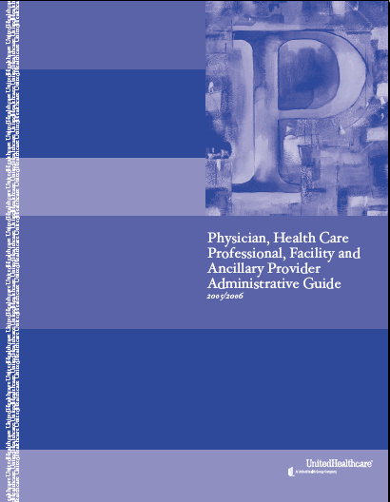
UnitedHealthcare Administrative Guide

Provider Participation Rules:
Optum Orthopedic Centers of Excellence Network
Health care providers participating in Optum’s Orthopedic Centers of Excellence network must abide with and by all provisions below. Failure to adhere to any provision will result in exclusion from the Orthopedic Centers of Excellence network.
Criteria
Optum, in conjunction with a multi-disciplinary panel of specialty physicians, develops proprietary criteria upon which you are evaluated for inclusion in Optum’s Orthopedic Centers of Excellence network. The evaluation criteria are updated periodically in response to emerging clinical data, or medical techniques and technologies. Optum’s Clinical Sciences Institute (CSI) department performs the health care provider evaluations on an initial and annual basis through a web based survey. You will be evaluated against the following benchmark criteria:
      - Volume of procedures
      - Outcomes – Patient length of stay, complication rates, and readmissions
      - CMS Certification
      - Maintenance of minimum malpractice insurance
      - Credentialing by United Health Networks
      - The Joint Commission (TJC) Accreditation (unless prohibited by state law)
      - Patient Education and Management
      - Clinical Research and Publications
If you do not comply with the following processes, you may be placed in a Focused Review or removed from the Orthopedic Centers of Excellence network.
Compliance with Optum’s Operations Guide
You must comply with all provisions located in Optum’s Operations Guide. This may include, but is not limited, to the following topics:
- Eligibility, Coverage, Prior Approval/Authorization Inquiries – Optum’s or Optum client’s directions should be followed for verifying a prospective patient’s eligibility and level of coverage. You may also be required to request prior approval/authorization on prospective patient’s behalf for services.
- Standards of Practice Guidelines – Optum, along with a panel of multi-disciplinary specialty physicians, may set standards of practice guidelines for orthopedics and orthopedic-related treatment of Optum members or Optum client’s members.
- Claims – The Optum Operations Guide contains information for proper claims submission. You need to fill out all applicable forms and fields before Optum will process the claims.
- Utilization Review Optum’s guidelines should be followed for furnishing Optum with a utilization review and the appropriate information to allow Optum to perform its own utilization review of a member’s inpatient stay.

Consultation
Please consult Optum’s CSI team at clinical.science@Optum.com regarding Optum’s medical policies, quality improvement programs, and utilization management procedures.
Mutually Acceptable Rates and Terms
You and Optum must agree to mutually acceptable rates and terms in the Orthopedic Services Agreement for your inclusion in Optum’s Orthopedic Centers of Excellence network. As detailed in the Orthopedic Services Agreement, you are reimbursed on a bundled case rate with no withholds or bonuses.
Optum’s Annual Survey
As a participating health care provider in Optum’s Orthopedic Centers of Excellence network, CSI will send you an annual survey. Health care Providers are given 30 days to complete and return the survey and if requested, may be given a 15-day extension. CSI evaluates your survey data comparing it to their proprietary criteria. If you meet the criteria, you will remain in Optum’s Orthopedic Centers of Excellence network. If you do not meet Optum’s criteria, you are subject to a Focused Review or change in network status.
Appeals Process
Your program may appeal Optum’s decision to change your programs network status under certain circumstances. Optum will send you a letter notifying you of your program’s removal from the Optum Centers of Excellence network. The letter will include the reason for the change in network status and will let you know the appeal rights that apply to the decision. Please note that not all adverse decisions are subject to appeal. It is important that you follow the process outlined in the letter.

MyOptumcomplexmedical.com – Provider Web site
Optum has developed a secured Web site to specifically address the needs of our contracted facilities. The Web site provides access to important information about your active and closed cases, clinical dates and claims information.
Web site Address: www.myOptumhealthcomplexmedical.com
Staff at your medical center can request access to the site by clicking on the link entitled ‘Request Access’ on the home page. Users are required to complete an online form requesting demographic and role-based information before access is granted to the site.
Optum grants access to affiliated providers upon approval from the medical center’s designated managed care contact person.

MyOptumhealthcomplexmedical.com – Login Page
Detailed explanation of processes and procedures for each area of the site is provided in Appendix A of this document.

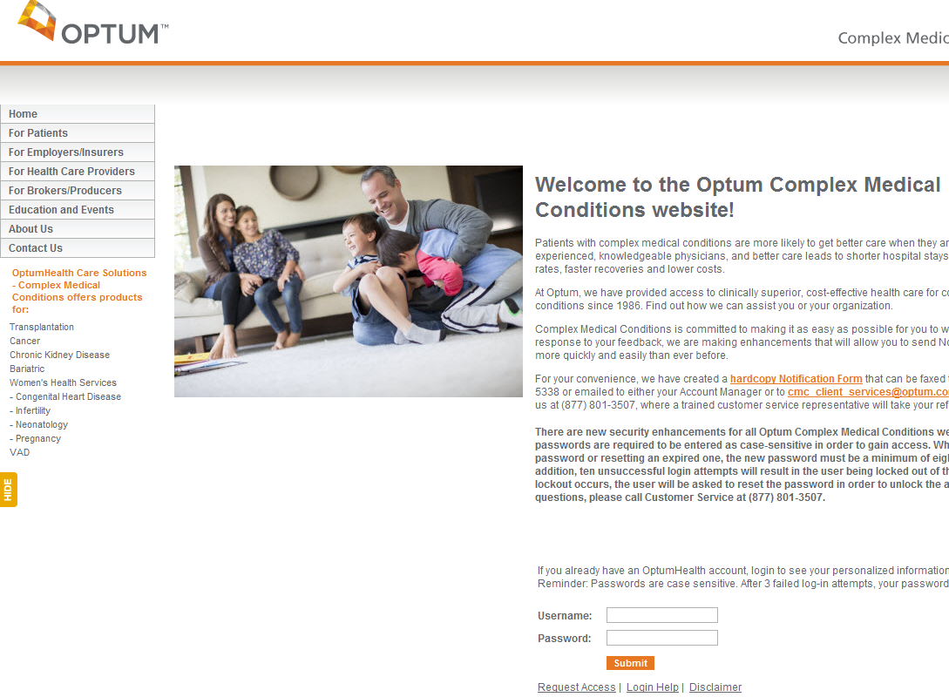
Your staff can request access here

Notification Form

Importance of the Notification Form
Optum patient referrals are communicated to our contracted orthopedic centers via the Notification Form (NF). The NF should be received prior to the patient’s first visit to your medical center and is used to provide your staff with key information about a patient who has been referred for orthopedic evaluation or treatment.
We suggest that distribution of this information occur as indicated below:
- Clinical staff should be given the contact name and phone number of the payer case manager. This information is used to obtain authorization for care and to provide updates on patient status.
- Billing and administrative staff are notified by the NF that claims are to be sent directly to Optum. Your facility is responsible for forwarding the NF to any affiliated entities or contacting your affiliates to provide the Optum case effective date and Optum billing address.
Additionally, we recommend that your administrative system be flagged so that the patient is identified as an Optum Orthopedic patient. This will help ensure that orthopedic-related claims are submitted to Optum
Reminder: It is your organization’s responsibility to verify patient benefits at the beginning of the case.

NF Process
The NF is completed by an Optum case manager/clinical consultant, or by an Optum customer and sent to Optum. A patient record is created within our systems based on the information provided on the NF. The NF is then forwarded to designated contacts at your medical center. (This contact information is collected within the health care provider RFI.)

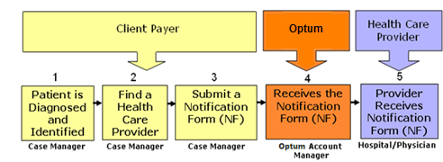
Process Flow for Orthopedic Notification Form
In some cases, there may be a 24-hour delay between your receipt of the NF and the new case appearing on the provider Web site.

Orthopedic Notification Form 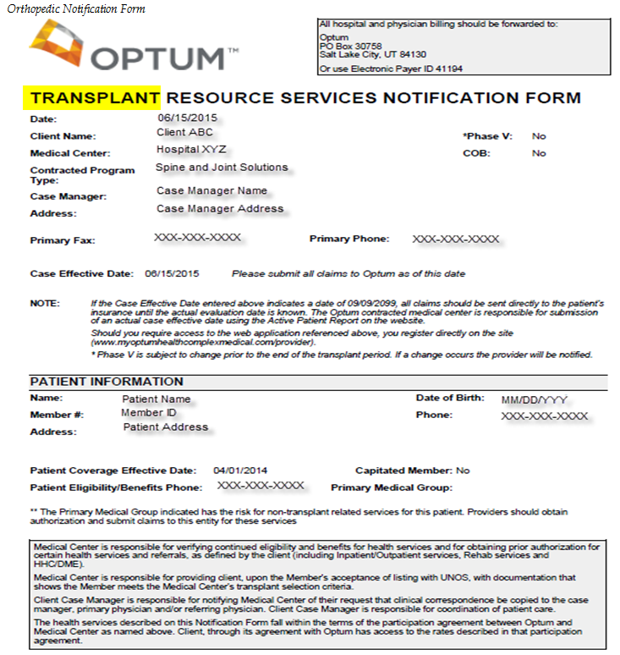
Orthopedic Resource Services Notification Form (NF)
*Due to system constraints Transplant program displays on Orthopedic Notification Form

Locating the Payer Case Manager on the NF
Optum or Payer case manager contact information is provided on the orthopedic notification form sent to the health care provider for each patient. This information is located in the upper-third of the form.

Communication with the Payer Case Manager
Payer case managers have a variety of critical responsibilities that vary from payer to payer. Normally, they are the contact point for information about benefit eligibility, eligible services, preauthorization of services and discharge planning.
It is important to keep in mind that Optum or the payer case manager is influential in referring patients to orthopedic centers. Their relationship with the clinical contacts within your orthopedic program, as well as the ease with which they can obtain the information they need, has an impact on referral decisions. Optum strongly encourages timely communication with payer case managers to help facilitate administration of patient care and timely payment of claims.

When to Contact the Payer Case Manager
Noted below is a table that can be used as a reference guide for communication with payer case managers.
When? | Call Who? | About What?
Initial Referral | Optum or Payer Case Manager | - Exchange contact information  - Discuss pre-certification process  - Choose facility  - Identify follow-up plans
Initial Referral | Referring Physicians | - Scheduled date of surgery or other treatment
Surgery | Optum or Payer Case Manager and Referring Physician | - Date of admission, pre-certification notification  - Establish follow-up plan for routine inpatient updates  - Discuss discharge planning at least 2 days prior to discharge:  - Home care needs  - DME needs  - Medication needs through an agreed-upon pharmacy  - Follow-up plans  - Establish ongoing communication plan
Post Surgery | Optum or Payer Case Manager and Referring Physician | - Discuss changes in patient status as needed.

Always contact the Payer Case Manager in the case of death. It is also important to keep the referring physician informed throughout the treatment process. Regular communication is the key.

Locating the Notification Form
The patient Notification Forms can be found on myOptumhealthcomplexmedical.com under the Manage Patient menu item (Manage Patients > Notification Form). Clicking on a patient name will open the NF (Adobe Acrobat Reader Required).
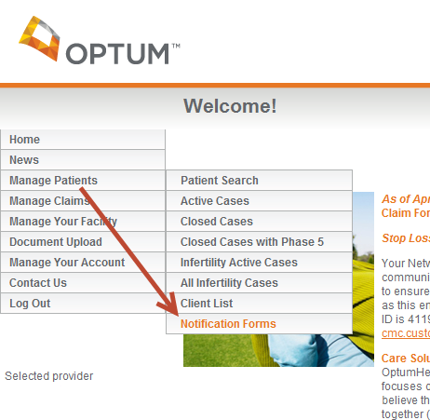
myOptumhealthcomplexmedical.com --- Notification Forms
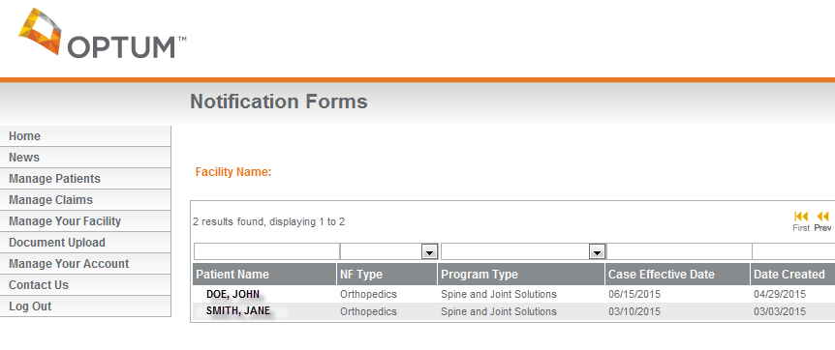

Active Network Client List
For an active client list, please outreach to SJS Product Team. In addition, our Nurse team has active client lists that they work from to ensure that members are sent as part of the bundle program are indeed part of groups that have access to these contracts.

Claims Submission
Claims must be sent to the Optum claims team for pricing. Once priced according to the contract, claims will be forwarded to Optum payers for payment. All claims submitted are priced based on the clinical date information entered on www.myOptumhealthcomplexmedical.com/provider website. Therefore, it is important that dates be verified on the Patient Detail page for accuracy prior to claims submission.

Where to Submit Claims
All claims filed 837 I & P as well as UB04 and HCFA1500 claims must be forwarded to Optum as indicated below:

Electronic Claims Payer ID Information
Optum Care Solutions
Payer ID #41194

Paper Claims Address Information
Optum Care Solutions
PO Box 30758
Salt Lake City, Utah 84130

Emergency Claims Submission
In cases of emergency, your medical center can submit claims to Optum using overnight delivery. Please call our toll-free number (877-801-3507) to provide us with notification of overnight claims delivery.
LASON – SCS RMO
Attention: Optum Care Solutions
PO Box 30758
Salt Lake City, Utah 84130
How and When to Submit Claims
Claims should be filed electronically or on paper in an 837 HIPAA compliant format on standard UB04 and HCFA1500 claims forms and completed using industry standard coding.
Timely Filing
Your medical center agreement contains a claim filing deadline. Please consult your agreement for the timely filing deadline for your medical center. Optum or its payers, at their discretion, may elect to not accept claims that are submitted after the timely filing deadline.

What Happens to Claims Upon Submission to Optum?
Claims submitted to Optum follow a defined process that allows for timely and accurate pricing prior to submission for payment by our payer customers. Health care provider staff can review the current pricing status of claims submitted on the Provider Web site.

Claims Intake and Pricing Process Flow
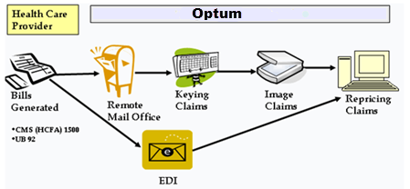
Claims Intake and Pricing Process Flow
A daily summary of claims submitted electronically to Optum can be viewed on myOptumhealthcomplexmedical.com. See Appendix A for details on the EDI Claims Inventory Report

Priced Claims Payment Process
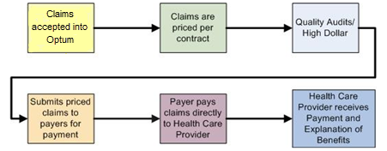
Priced Claims Payment Process
After Optum prices the claims, they are sent to clients along with a report explaining the claims. See Appendix C for an example of a Client Claims Report.

Claims
Claims submitted to Optum can be viewed on the MyOptumhealthcomplexmedical.com Web site in two locations: EDI Claims Inventory Summary and Patient Claims List.
Electronic Claims Summary
Your medical center can view claims submitted electronically via the Optum EDI Claims Inventory tool. The Electronic Claims Inventory is located under the Manage Claims menu item (Manage Claims > EDI Claims Inventory). Details on the Electronic Claims Inventory are available in Appendix A.
Note: If your organization does not submit claims electronically, this web page will be blank.
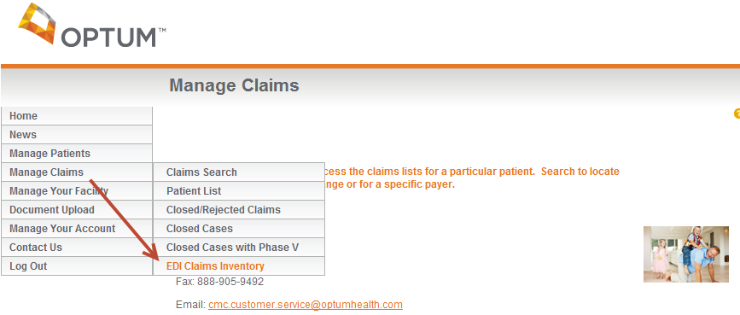
MyOptumhealthcomplexmedical.com – EDI Claims Inventory Summary

Claims that are Closed or Sent Back to the Health Care Provider
Occasionally Optum will close claims submitted by health care providers and accepted into our system. Reasons for claims closure include:
- Duplicate claims
- Missing or invalid data
- Claim submission by an unaffiliated provider. This means only providers who have agreed to the Optum bundled contract in place should submit claims to Optum.
- Claims dates of service that do not fall into the eligibility period for the patient
Some claims are rejected before entry into our system because the patient’s name, date of birth or the health care provider’s tax identification number does not match information set up for the patient’s case or the medical center.
Please Note: Optum does not return duplicate claims to the health care provider.

Missing Claims
If your medical center has submitted a claim that does not display on the Patient Claims and you cannot locate the claim online within one week of its submission, please resubmit the claim to Optum.

Patient Claims List on www.myOptumhealthcomplexmedical.com
The Patient List shows all claims received by Optum, by patient name. The Patient List is located under the Manage Claims menu item (Manage Claims > Patient List).
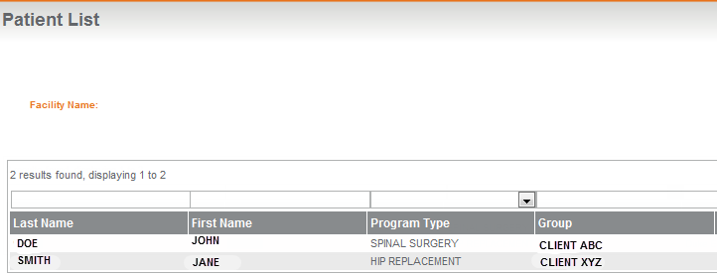

MyOptumhealthcomplexmedical.com – Patient List
All claims for individual patients shown on the claims list can be viewed by simply clicking on the patient’s name (the patient name is a hyperlink). You can also access the Patient Claims List from the Manage Claims menu item (Manage Claims > Patient List > select your patient.
Summary case information (including clinical dates) is provided on this page, including:
- Program type
- Case effective date
- Inactive date
- Case close reason
An additional search feature provides the ability to search for claims by date of service (DOS). Details on the Patient Claims List are available in Appendix A.

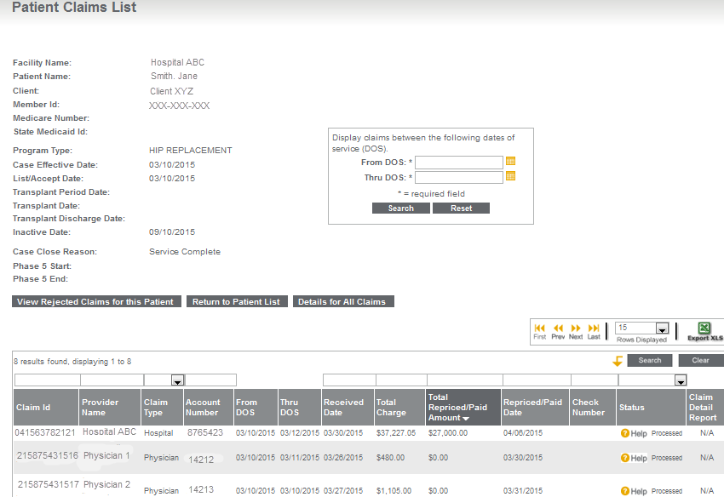 MyOptumhealthcomplexmedical.com – Patient Claims List

Checking Re-priced Claims
You can check the processing status of your claims directly on the MyOptumhealthcomplexmedical.com Web site. The Patient Claims List displays the claim ID number and status of each claim. Claims that have been priced will display a status of ‘processed’. These claim numbers always end in ‘00’. The processed status means that Optum has priced the claim based on the contractual agreement with your medical center.
If the claim requires adjustment, it will be priced again. A second line of information will display reflecting this status. The status on the original claim line item will change to ‘adjusted.’ The second line will display a status of ‘processed.’ The last two digits of the claim ID will also change to ‘01’. This also indicates that an adjustment to the original claim has been made. The original claim remains available for view with the original claim number.
MyOptumhealthcomplexmedical.com – Adjusted Claim on Patient Claims List

Manage Claims – Patient Claims Detail
You can view details about each claim listed on the Patient Claims List by clicking on the claim number (a hyperlink appears directly under the claim number) or the View All Claim Detail button at the bottom of the page. You can access the Patient Claim Detail page from the Manage Claims menu item (Manage Claims > Patient List > select your patient > select the claim number.) Details on the Patient Claim Detail page are available in Appendix A.
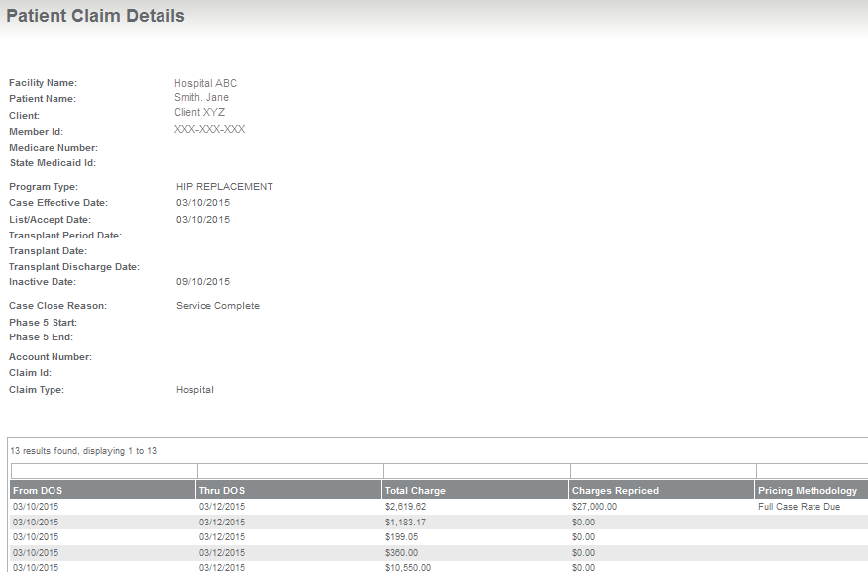

MyOptumhealthcomplexmedical.com – Patient Claim Details

Claims Pricing and Payment Process

Process Overview and Guidelines
- Optum prices claims received from your medical center based on your specific Optum agreement.
- Optum sends priced claims to payers for processing.
- Optum payers apply patient benefits to the priced claim amount and determine which services are eligible for reimbursement. Member responsibility amounts such as co-payments, coinsurance and deductibles are applied.
- Your medical center may bill the patient for any amounts that are the responsibility of the patient. These amounts will be shown as patient responsibility on the explanation of benefits/health care provider remittance advice.
- If there is an overpayment, Optum will notify your medical center of the overpayment via a Refund Notice. We will also notify the payer of an underpayment on the final invoice.

Closed Case List on www.myOptumhealthcomplexmedical.com
We provide a Closed Case list on the provider Web site.
- Cases without any claims submitted in the previous 24 months are visible in this area. This list can be accessed on the site from the Manage Claims menu item (Manage Claims > Closed Cases). Details on the Closed Case List are available in Appendix A.
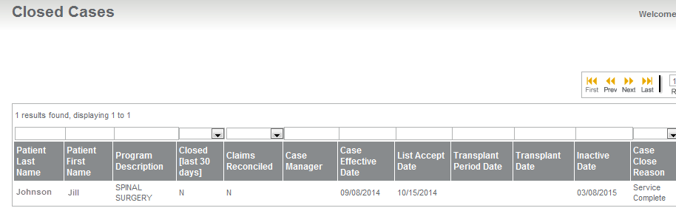
The Closed Case Reports on myOptumhealthcomplexmedical.com are also accessible under the Manage Patients and Manage Claims menu items.

Claims Status Process
You can view the pricing status of claims submitted by your medical center using the Patient Claims List on MyOptumhealthcomplexmedical.com. If after 45 days from the priced date you do not have payment from a payer, you can submit a claims inquiry to Optum Inquiries are tracked by the Network Relations team. Assigned team members will contact payers, as needed, to verify payment status.
There are three ways you can submit inquiries as illustrated in the table below:
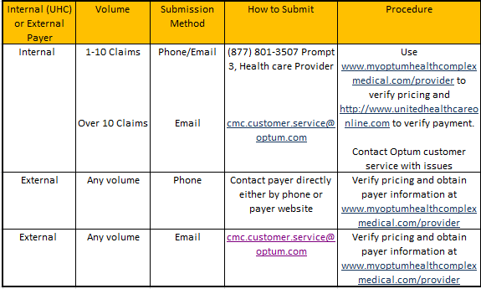
Optum Claims Status Submissions
Additionally, you can use the Patient Claims List on MyOptumhealthcomplexmedical.com to export a list of claims to Microsoft Excel. By doing so, you can customize the information submitted for status and send to Optum via secure email.
Be sure to review the claims status guidelines that are posted on MyOptumhealthcomplexmedical.com (Manage Claims > Claims Status Spreadsheet Template) for additional details.
The following is a summary of the Network Services Policy covering handling of Customer Service Inquiries:
Following submission of an inquiry, you will be issued an inquiry ID number to track the progress of your status request to resolution. If you submit your request by phone, the inquiry ID number will be provided by the end of the call. If your request was submitted via fax or email, the inquiry ID number will be returned within 24 hours to the contact provided on the request.
Your Network Relations Representative will provide regular status updates on the resolution of your request. The frequency of these updates will vary depending on the number of cases, claims and payer(s) included in the request.

Appendix A: Provider Page Examples and Field Descriptions
This appendix provides details of the pages available within the Provider Web site. A graphic of each page is provided accompanied by descriptions of each field. Navigation to the page is also indicated.
For additional information or training on the site, please contact your Network Relations Representative.

Active Case List
This read-only page provides a list of all active cases at your medical center. The fields located above the column headings allow sorting and/or filtering on one or more fields of data. To access Patient Detail or notes, simply click on the patient name hyperlink.
Note: You can use the field or drop down list above the Program Type field to see only patients.
This information can also be exported in either Excel or PDF formats.
Navigation: Manage Patients > Active Cases
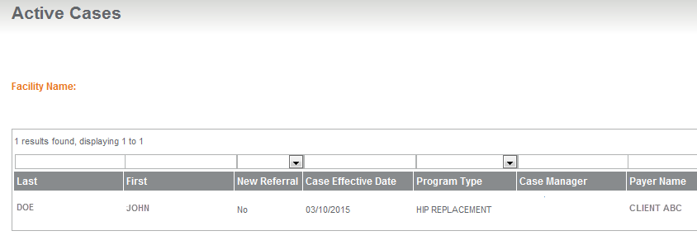

Active Case List
Field Name | Field Description
Last | Displays the patient’s last name. Each name links to the Patient Detail page.
First | Displays the patient’s first name. Each name links to the Patient Detail page.
CED | Displays the case effective date (CED) for the case.
New Referral | Yes/No field that indicates whether the case is a new referral within the last 30 days.
Program Type | Displays the orthopedic program accessed by the patient.
Case Manager | Displays the payer case manager’s name and phone number.
Payer Name | Displays the payer for the patient.
Status | Displays the current case status for the patient.
Change Status | Displays the last date status was changed on the patient record.

Patient Detail
This page displays details of the patient’s case. Users with access can enter surgical dates and notes on the case. The patient notes link accesses the Patient Notes page allowing case note entry.
Navigation: Manage Patients > Active Cases > select your patient

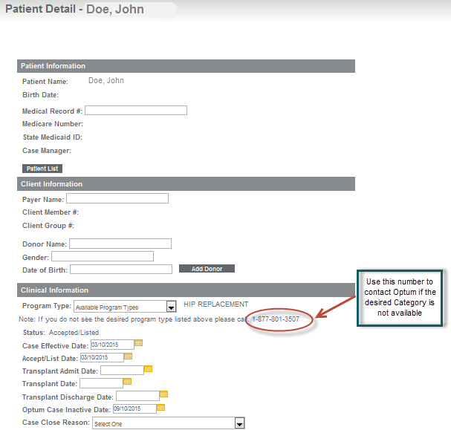
Active Case -- Patient Detail
Field Name | Field Description
Patient Name | Displays the patient’s name.
Birth Date | Displays the patient’s date of birth.
Medical Record # | Optional field that allows you to enter your medical center’s medical record number for the patient.
Case Manager | Displays the payer case manager’s name and phone number.
Payer Name | Displays the payer’s name.
Client Member # | Displays the payer’s (customer) member number.
Client Group # | Displays the payer’s (customer) group number.
Donor Name | Not applicable to Orthopedic cases.
Gender | Not applicable to Orthopedic cases.
Date of Birth | Not applicable to Orthopedic cases.
Program Type | Displays the orthopedic program accessed by the patient.
Status | Displays the current status for the patient.
Case Effective Date | Allows for entry and display of the case effective date (CED) for the case.
Accept/List Date | Not applicable to Orthopedic cases.
Transplant Admit Date | Allows for entry of the admission date for the surgery.
Transplant Date | Allows for entry of the surgery date for the patient.
Transplant Discharge Date | Allows for entry of the date the patient was discharged from the health care provider.
Optum Case Inactive Date | Allows for entry of an inactive date for the case.
Case Close Reason | Once an inactive date has been entered, a case close reason must be selected from the drop-down.
Comments | A text field allowing a comment when the case has been closed for the reason ‘Other’.
Patient Notes Link | Clicking on this link opens the data entry form for patient notes.
Date | Displays the date of existing patient notes.
Entered by | Displays the name of the user entering the patient note.
Notes | Displays the text of the note entered.

Patient Notes
Navigation: Manage Patients > Active Cases > select your patient > Patient Notes

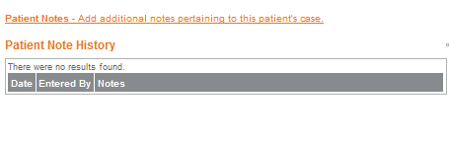

Active Case – Patient Detail & Patient Notes
Field Name | Field Description
First Name | Displays the first name of the person entering the patient note.
Last Name | Displays the last name of the person entering the patient note.
Date | Displays the date that the patient note was entered.
Notes | Displays the text of the patient note.
Enter Patient Notes | Text field allowing entry of a patient note.
Save button | Saves the patient note.
Back button | Returns the user to the Patient Detail page.

Closed Case List
The Closed Case list shows all cases with a current status of closed. The fields located above the column headings allow sorting and/or filtering on one or more fields of data. To access patient detail, simply click on the patient name.
This information can also be exported in either Excel or PDF formats.
Navigation: Manage Patients > Closed Cases or
Manage Claims > Closed Cases

Closed Cases
Field Name | Field Description
Patient Last Name | Displays the last name of the patient.
Patient First Name | Displays the first name of the patient.
Patient Name | Links to any patient notes.
Program Description | Displays the orthopedic program accessed by the patient.
Closed [last 30 Days] | Yes/No flag that indicates whether the case has been closed within the last 30 days.
Claims Reconciled | Yes/No flag that indicates if claims for the case have been reconciled.
Case Manager | Displays the payer case manager’s name.
Case Effective Date | Displays the case effective date (CED) for the case.
List Accept Date | Not applicable to Orthopedic cases.
Transplant Period Date | Not applicable to Orthopedic cases.
Transplant Date | Displays the date of the patient’s surgery.
Inactive Date | Displays the inactive date for the case.
Case Close Reason | Displays the reason the case was closed.
Phase 5 Start | Not applicable to Orthopedic cases.
Phase 5 End | Not applicable to Orthopedic cases.

Patient List (Claims)
The Patient List is a read-only search screen. The fields located above the column headings allow sorting and/or filtering on one or more fields of data. To access the patient claim information, simply click on the patient name.
This information can also be exported in Excel or PDF formats.
Navigation: Manage Claims > Patient List
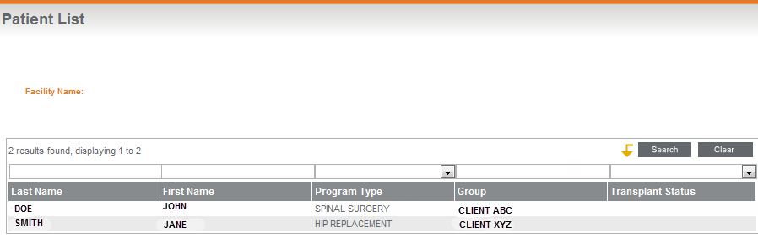

Patient List
Field Name | Field Description
Facility Name | Displays the health care provider name.
Last Name | Displays the last name of the patient.
First Name | Displays the first name of the patient.
Program Type | Displays the orthopedic program accessed by the patient.
Group Name | Displays the payer group name.
Transplant Status | Displays the current status.

Patient Claims List
The Patient Claims List shows all claims processed by Optum for an individual patient. The fields located above the column headings allow sorting and/or filtering on one or more fields of data. To access detail on an individual claim, simply click on the claim ID hyperlink.
This information can also be exported in Excel or PDF formats.
There is also a date of service (DOS) search feature that can be used to locate claims for the patient during a specified date range.
Navigation: Manage Claims > Patient List > select your patient
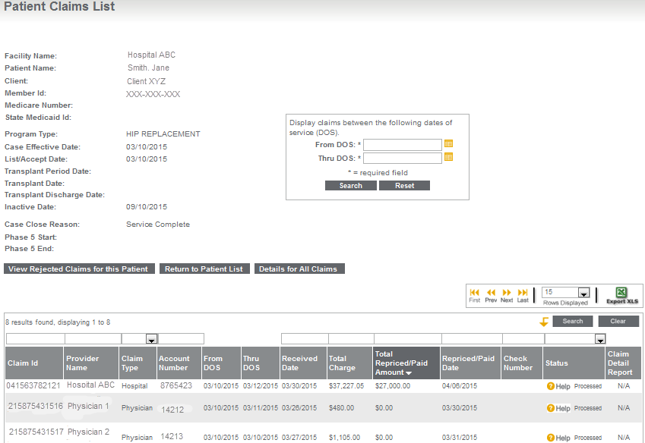
Patient Claims List
Field Name | Field Description
Facility Name | Displays the health care provider name.
Patient Name | Displays the patient’s first and last name.
Client: | Displays the payer’s name.
Member ID | Displays the patient’s member ID as entered on the Patient Detail page.
Program Type | Displays the orthopedic program accessed by the patient.
Case Effective Date | Displays the case effective date (CED) for the case.
List/Accept Date | Not applicable to Orthopedic cases.
Transplant Period Date | Not applicable to Orthopedic cases.
Transplant Date | Displays the date of the patient’s surgery.
Inactive Date | Displays the date the case was closed.
Case Close Reason | Displays the reason the case was closed.
Phase 5 Start | Not applicable to Orthopedic cases.
Phase 5 End | Not applicable to Orthopedic cases.
Claim ID | Displays the claim ID number.
Provider Name | Displays the name of the provider that submitted the claim.
Claim Type | Displays the type of claim submitted (physician or hospital).
Account Number | Displays the account number provided on the claim.
From DOS | Displays the start date of services on the claim.
Thru DOS | Displays the end date of services on the claim.
Claim Received Date | Displays the date the claim was received by Optum.
Total Charge | Displays the total charge on the claim.
Total Re-priced | Displays the re-priced amount of the claim.
Claim Re-priced Date | Displays the date the claim was re-priced by Optum.
Check Number | Not applicable to Orthopedic cases.
Status | Displays the claim’s current pricing status.
Details for All Claims | This button opens a page listing line item detail of all claims for the patient.

Patient Claim Detail
The Patient Claim Detail page provides line item detailed information on an individual claim. Simply click on the Claim ID number to access line item detail for that claim. The fields located above the column headings allow sorting and/or filtering on one or more fields of data. To access detail on an individual claim, simply click on the claim ID hyperlink.
This information can also be exported in Excel or PDF formats.
Navigation: Manage Claims > Patient List > select your patient > select the claim ID number
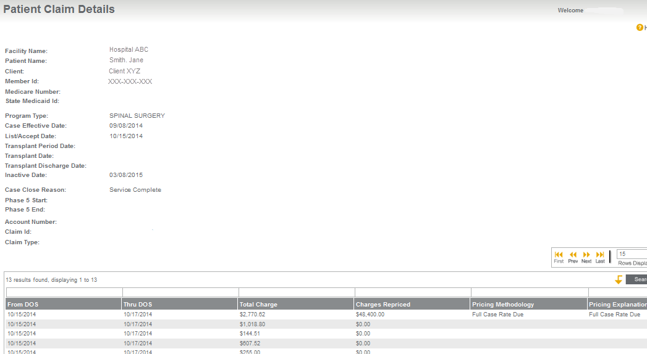
Patient Claim Details
Field Name | Field Description
Facility Name | Displays the health care provider name.
Patient Name | Displays the patient’s first and last name.
Client: | Displays the payer’s name.
Member ID | Displays the patient’s member ID as entered on the Patient Detail page.
Program Type | Displays the orthopedic program accessed by the patient.
Case Effective Date | Displays the case effective date (CED) for the case.
List/Accept Date | Not applicable to Orthopedic cases.
Transplant Period Date | Not applicable to Orthopedic cases.
Transplant Date | Displays the date of the patient’s surgery.
Transplant Discharge Date | Displays the discharge date of the patient.
Inactive Date | Displays the date the case was closed.
Case Close Reason | Displays the reason the case was closed.
Phase 5 Start | Not applicable to Orthopedic cases.
Phase 5 End | Not applicable to Orthopedic cases.
From DOS | Displays the start date of services on the claim.
Thru DOS | Displays the end date of services on the claim.
Total Charges | Displays the charges billed on the claim.
Charges Re-priced | Displays the re-priced amount of the claim.
Pricing Methodology | Displays the pricing methodology used to price the claim.
Pricing Explanation | Displays an explanation of how the claim was re-priced based on the health care provider agreement.

All Claims Line Item Detail
The All Claims Detail page provides line item detailed information on every claim submitted. The fields located above the column headings allow sorting and/or filtering on one or more fields of data. To access detail on an individual claim, simply click on the claim ID hyperlink.
The information displayed can also be exported in Excel or PDF formats.
Navigation: Manage Claims > Patient List > select patient name > Details for All Claims (at bottom)
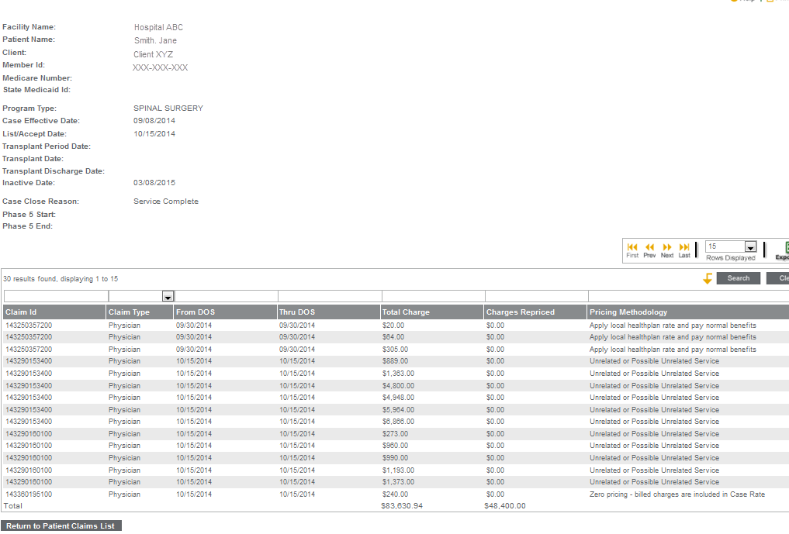
Patient All Claims Detail
Field Name | Field Description
Facility Name | Displays the health care provider name.
Patient Name | Displays the patient’s first and last name.
Client: | Displays the payer’s name.
Member ID | Displays the patient’s member ID as entered on the Patient Detail page.
Program Type | Displays the orthopedic program accessed by the patient.
Case Effective Date | Displays the case effective date (CED) for the case.
List/Accept Date | Not applicable to Orthopedic cases.
Transplant Period Date | Not applicable to Orthopedic cases.
Transplant Date | Displays the date of the patient’s surgery.
Transplant Discharge Date | Displays the discharge date of the patient.
Inactive Date | Displays the date the case was closed.
Case Close Reason | Displays the reason the case was closed.
Phase 5 Start | Not applicable to Orthopedic cases.
Phase 5 End | Not applicable to Orthopedic cases.
Claim ID | Displays the claim ID number.
Claim Type | Displays the type of claim submitted (physician or hospital).
From DOS | Displays the start date of services on the claim.
Thru DOS | Displays the end date of services on the claim.
Total Charge | Displays charges billed on the claim.
Charges Re-priced | Displays re-priced amount of the claim.
Pricing Methodology | Displays the pricing methodology used to price the claim.

Electronic Claims Inventory Summary
The Electronic Claims Inventory Summary page provides a daily summary of the status of claims submitted through EDI. This page displays the number of electronic claims received along with the processing status of the claim(s). To access claim detail information for a specific day, simply click row for the date and you will access the EDI Claim Inventory Detail page.
The information displayed can also be exported in Excel or PDF formats.
Navigation: Manage Claims > EDI Claims Inventory > select the health care provider
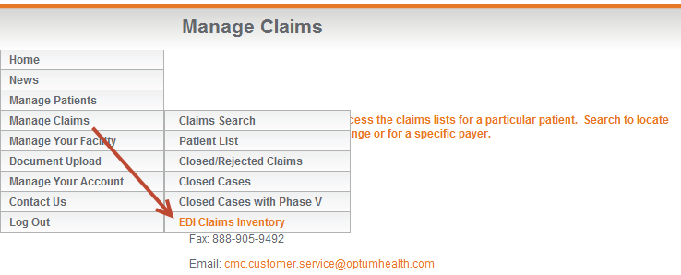

EDI Claims Inventory Summary
Field Name | Field Description
Date | Displays the date the electronic claims were received by Optum.
Status | Displays the processing status of the claim(s).
Count | Displays the number of claims for each status.

Electronic Claims Inventory Detail page
The Electronic Claims Inventory Detail page provides the detailed electronic claim information for each claim received on that date, including the claim processing status.
The information displayed can also be exported in Excel or PDF formats.
Navigation: Manage Claims > EDI Claims Inventory > select the health care provider > select a date
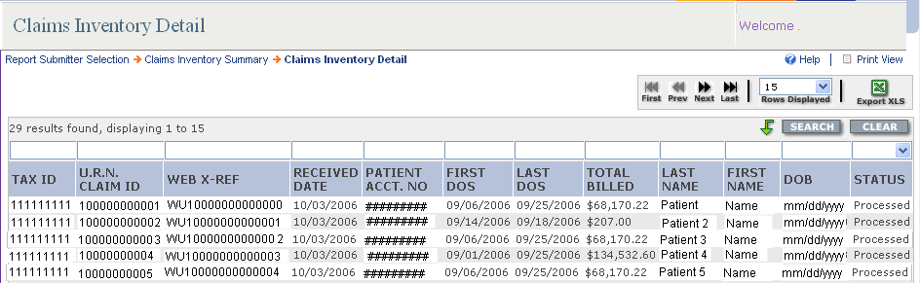

EDI Claims Inventory Detail
Field Name | Field Description
Tax ID | Displays the tax ID of the health care provider submitting the claim.
OPTUM Claim ID | Identifies the claim number for Optum’s claim system.
Web X-Ref | Identifies the web reference number from the clearinghouse.
Date Received | Displays the date the electronic claim was received.
Patient Acct No | Displays the patient account number submitted on the electronic claim.
First DOS | Identifies the first date of service on the claim submitted.
Last DOS | Identifies the last date of service on the claim submitted.
Total Billed | Displays the total billed charge amount on the claim submitted.
Last Name | Displays the last name of the patient for which the claim was submitted.
First Name | Displays the first name of the patient for which the claim was submitted.
DOB | Displays the date of birth for the patient.
Status | Displays the processing status of the claim(s).

APPENDIX B: GLOSSARY OF Terms & Acronyms

Glossary of Terms
Note: If there is a discrepancy between a definition in this Operations Guide and a definition in your Agreement with Optum, the definition in the Agreement supersedes the definition in this guide.
Affiliated Provider | A physician, health care provider or sub-contracted entity that is a party to the health care provider contract with Optum.
Allowable Costs | Charges for services rendered for supplies furnished, by any health care provider, that qualify as covered expenses.
Allowable Days | The inpatient days associated with a case rate.
Billed Claims | The fees for health care services provided to a covered person and submitted by a health care provider. Also referred to as billed charges.
Case Manager | A clinical professional (e.g., nurse, doctor or social worker) who works with patients, health care providers, physicians and insurers to determine and coordinate a plan of medically necessary and appropriate health care. Also referred to as care coordinator.
Ceiling | An operational term used to indicate the stop loss language in some health care provider contracts indicating that the health care provider payment will never be greater than the contract-defined percentage. Also referred to as “inlier.”
Centers of Excellence | A network of qualified health care facilities selected for specific services based on stringent criteria including outcomes and efficiency. For example, an organ transplant managed care program may require members to access transplant services through a Centers of Excellence network.
Claim | Information submitted by a health care provider or covered person that establishes the specific health services provided to a patient and requests reimbursement to the requestor.
Coinsurance | The portion of covered health care costs for which the covered person is financially responsible, usually according to a fixed percentage. Coinsurance often is applied, according to a fixed percentage, after a deductible requirement is met.
Coordination of Benefits (COB) | A provision in a contract that applies when a person is covered under more than one group medical program. It requires that payment of benefits be coordinated by all programs to eliminate over-insurance or duplication of benefits.
Co-payment | A cost-sharing arrangement in which a covered person pays a specified charge for a specified service, such as $10 for an office visit. The covered person usually is responsible for payment at the time the health care is rendered. Typical co-payments are fixed or variable flat amounts for physician office visits, prescriptions or hospital services. Some companies use the term co-payment to refer generically to both a flat dollar co-payment and coinsurance.
Date of Service | The date health care services were provided to the covered person.
Effective Date | The date a contract becomes effective.
Electronic Data Interchange | The computer-to-computer exchange of business or other information between two medical centers (trading partners). The data may be either in a standardized or proprietary format. Also known as electronic commerce.
Eligibility Dates | For purposes of your contract with Optum, this term does not refer to the patient’s benefit eligibility. See clinical dates.
Explanation of Benefits (EOB) | The coverage statement sent to covered persons listing services rendered, amount billed and the payment made.
HCFA1500 | A universal form, developed by the government agency known as Health Care Financing Administration (HCFA), for providers of services to bill professional fees to health carriers.
Inlier | An operational term used to represent the stop loss language in some health care provider contracts indicating that the health care provider payment will never be greater than the contract-defined percentage.
Member | A person who has been enrolled in a health care delivery system during the reporting period. Members include all people directly enrolled (enrollees/subscribers) and their eligible dependents. Also known as covered person and plan participant.
Outcomes | Results achieved through a given health care service, prescription drug use or medical procedure.
Paid Claims | The amounts paid to satisfy the contractual liability of the carrier or plan sponsor. These amounts do not include any covered person liability for ineligible charges or for deductibles or co-payments. If the carrier has preferred payment contracts with providers (e.g., fee schedules or capitation arrangements), lower paid claims liability usually result.
Payer | A medical center that pays for health care coverage expense. At OPTUM, this word also describes our customers.
Per Diem | An all-inclusive per-day rate for a specific service or bed type. Per diem rates are usually negotiated with hospitals for inpatient services or with ancillary providers for per-day services.
Percent of Charge | A reimbursement method that uses a percent discount for the provider’s actual billed charge to calculate the amount to be paid to the health care provider. Also referred to as a Percent of Billed Charges.
Procedure Rate | A payment made to a healthcare provider for a defined set of services during a specified period of time, as defined by the health care provider arrangement.
Provider | A physician, hospital, group practice, nursing home, pharmacy or any individual or group of individuals that provides a health care service.
Qualification | The process of reviewing a provider applicant to participate in a health plan. Specific criteria and prerequisites are applied in determining initial and ongoing participation in the health plan.
Repriced Claim | A claim that has the Optum negotiated rate applied based on the individual health care provider agreement.
RFI | Documents from Optum that collect critical health care provider operational and contact information.
Termination Date | The date that a group contract expires; or the date that a subscriber and/or covered person ceases to be eligible.
Unbundling | Separately packaging costs or services that might otherwise be billed together. For claims processing, this includes providers billing separately for health care services that should be combined according to industry standards or commonly accepted coding practices.
Uniform Billing Code of 2004  (UB-04) | A revised version of the UB-92, a federal directive requiring a hospital to follow specific billing procedures, itemizing all services included and billed on each invoice, which was implemented in 2004.

Glossary of Acronyms
Listed below are commonly used acronyms. Those rows highlighted below are specific to Optum.
CED | Case Effective Date
CM | Case Manager
COB | Coordination of Benefits
COE | Centers of Excellence network
CSI | Clinical Sciences Institute (Optum)
DOS | Date of Service
EDI | Electronic Data Interchange
HCFA1500 | Physician claim form
ID | Identification #. Typically associated with Claim ID or Member ID.
LOS | Length of Stay
NF | Notification Form
PDF | Portable Document Format
RFI | Request for Information
RMO | Remote Mail Office
UB04 | Uniform Billing Code of 2004; also known as the hospital claim form
myOptumhealthcomplexmedical.com | Optum’s secured web site for contracted facilities

